WordPress Site and Plugin

Documentation Guide

Team SCL in Alphabetical Order:

Jonathan Hou

Betsy Li

Vanessa Nguyen

Drake Song

# Table of Contents, Ctrl + Click to hop to that section

**Creating a WordPress Website** 3

Introduction 3

Creating an Account for Hosting Site 3

Starting a WordPress Site 3

Afterwards 3

How do I access the Admin page for my WordPress site? 3

My website is down! What do I do? 3

**Creating a Child Theme and Editing It** 4

Creation 4

Editing 4

**Making Categories and Tags** 5

Introduction 5

Making Categories 5

Making Tags 7

**Changing Social Media Links** 8

**Adding Plugins to WordPress** 9

Installation 9

Configuration 9

Add Search to Menu 9

Contact Form 7 11

Event Organizer 12

Give Donation 17

Google Analytics 23

Memphis Documents 24

Search & Filter 37

Ultimate FAQ 39

# Creating a WordPress Website

## Introduction

This is a how-to guide that goes through the steps taken to create the WordPress page that is being used as a prototype currently. It is important to note that there are multiple ways of achieving the same result. The method discussed in this guide is one of the simple methods that one can take in creating a WordPress page.

## Creating an Account for Hosting Site

First, it is important to set up a hosting site. The host used for the prototype is [000webhost](https://www.000webhost.com/) which is one of the many free hosting sites available. When you get to the site, there should be a Free Sign Up button either in the middle of the page or the top right corner of the page. Using your email, sign up for a free account.

After you have signed up for an account, check your email for a confirmation email. You must confirm before creating a website. When you click on the V*erify email* button in your email, it will take you back to 000webhost where an Email verified! message will appear.

## Starting a WordPress Site

On the top left corner of the page you're currently on, there is a *Build website* button with a picture icon. Click on it. This will then take you to a page with three big buttons in the middle: *Build a Website Easily, Build WordPress Website*, and *Upload Own Website*. Click on the *Build WordPress Website*. A pop-up will appear with the *WordPress install* header. Fill out the required information and press *Install*. 000webhost will then automatically create a WordPress site for you which you can view right away.

## Afterwards

### How do I access the Admin page for my WordPress site?

To access the admin page for the WordPress website, include */wp-admin* to the end of your URL (e.g. operationscl.000webhostapp.com/wp-admin) and log in using the admin login and password you set during the *WordPress install* popup.

### My website is down! What do I do?

Because 000webhost is a free hosting site, there are times when your website will be unavailable due to the free service. In addition, it is important to note that for all the sites created using a free account, ***there is an hour in which the website will go down***. However, you can set when the website will go down through 000webhost.

# Creating a Child Theme and Editing It

## Creation

Need to compress square-child files into a ZIP folder before the initial upload onto Wordpress, or log onto the server host (webhost000.com or hostinger.com for this site) and upload the file through there (can also use an FTP client but had trouble doing this). The child theme needs a style.css and a functions.php file (the format of these files can be found in the link below). Activate the child theme once you make it.

[Useful Link on Making Child Themes](https://codex.wordpress.org/Child_Themes)

## Editing

You can update the files through the WordPress editor by copying and pasting changes, or by reuploading the files through the server host or an FTP client. If you want to add new files you have to upload them.

Child theme functions.php gets added along with the parent theme functions.php. To edit a specific page (ex. the homepage or search page), you can make a new file in the child theme with the same name as the file in the parent theme.

You can edit the CSS with the built in Custom CSS in WordPress when you click on *Customize* for a theme, but you can also edit the CSS through the style.css file in the child theme. It's best to have your CSS in the style.css sheet too (just copy and paste it), that way you can have it on file.

PHP and JavaScript codes and examples can be found online through Google searches.

* This information is also found under */Wordpress site codes/README*

# Making Categories and Tags

## Introduction

This is a how-to guide that goes through the steps to make categories and tags on the WordPress site. Categories are mainly used for broad subjects that apply to multiple posts, while tags are more specific and apply to fewer posts. It is important to note that there are multiple ways of achieving the same result. To do the following steps, log onto an admin account for the WordPress website.

## Making Categories

On the side menu, hover over one of your post type denoted by the pin symbol. The *Posts* button is being hovered over, giving a sub-menu. (CatTagSS01) Click *Categories* in the sub-menu (CatTagSS01).

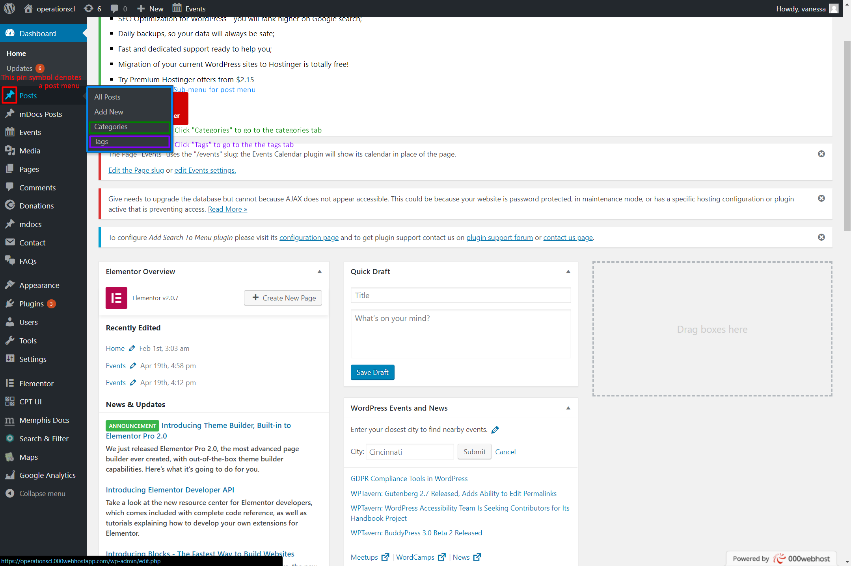

CatTagSS01

Making Categories and Tags (cont.)

Making Categories (cont.)

Type in the name of your new category under "Name" and a short version of the name for the url under "Slug" (CatTagSS02). If you are going to use the Search and Filter plugin for the site, it is probably best to leave the "Parent Category" as "None". You can make each category as a different form of posts on your website (ex. normal posts can be "Uncategorized" while posts from Memphis Docs can be "Archive", letting you filter between normal posts and Memphis Docs posts that contain archive content). You can add in a description for your category if you want to but it is not necessary. Hit "Add New Category" to make your new category.

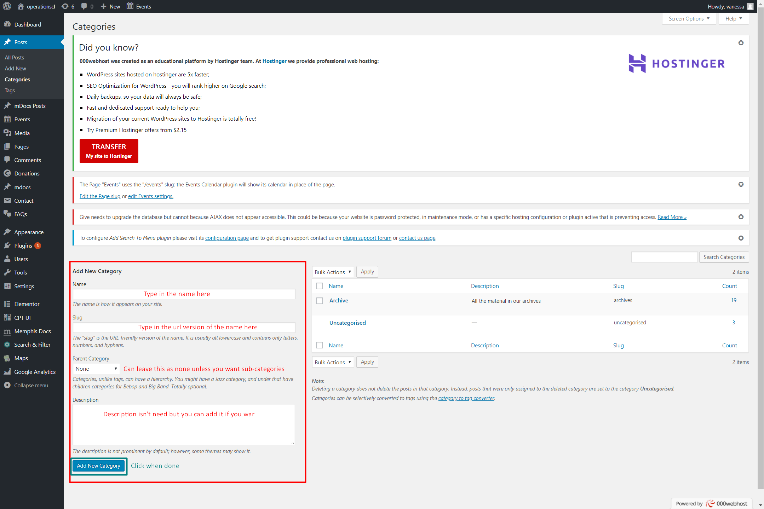CatTagSS02

Making Categories and Tags (cont.)

## Making Tags

On the side menu, hover over one of your post type denoted by the pin symbol. The *Posts* button is being hovered over, giving a sub-menu (CatTagSS01). Click *Tags* in the sub-menu (CatTagSS01). Type in the name of your new tag under "Name" and a short version of the name for the url under "Slug" (CatTagSS03). You can add in a description for your tag if you want to but it is not necessary. Hit "Add New Tag" to make your new tag.

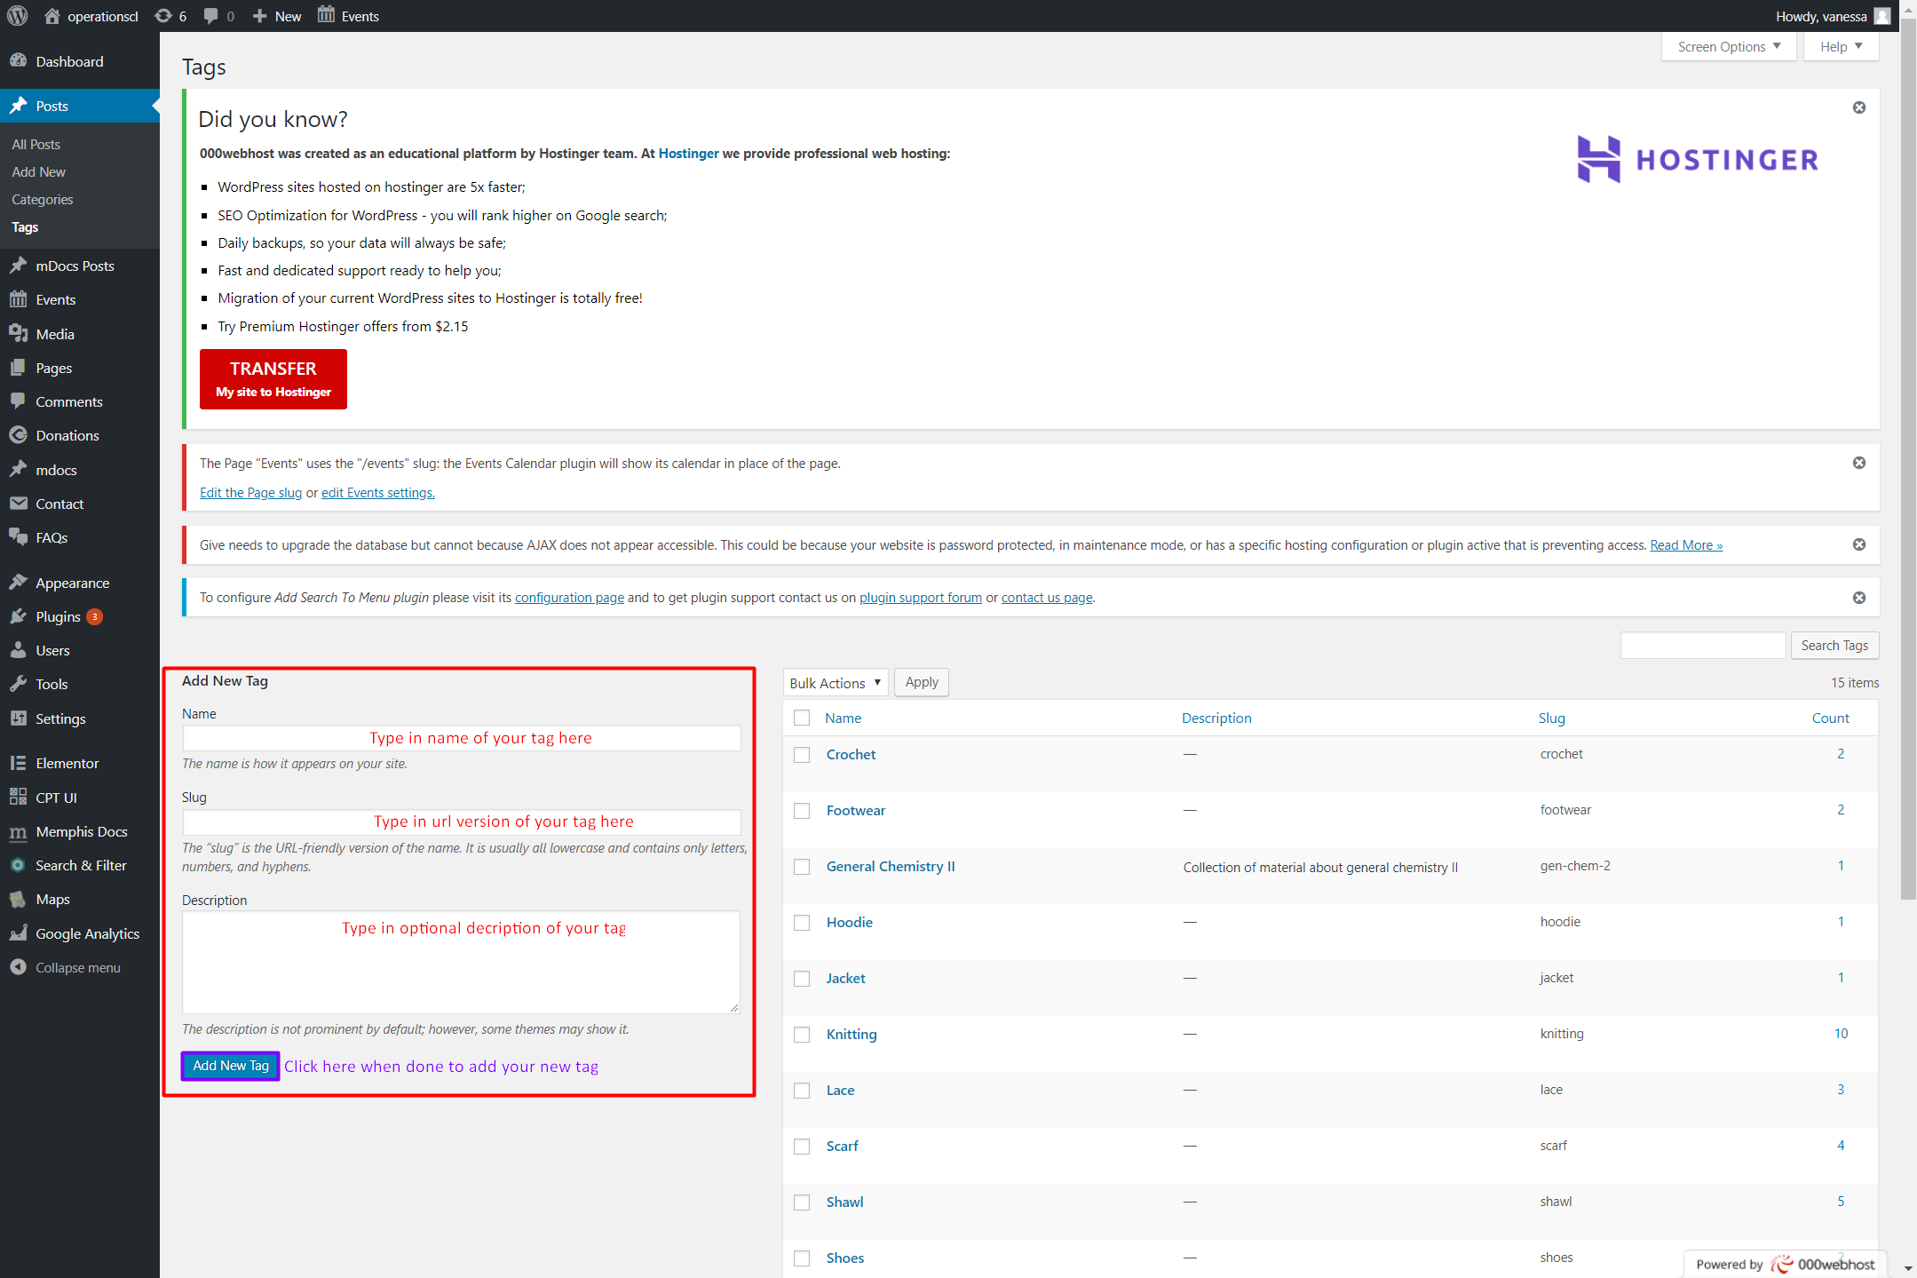

CatTagSS03

# Changing Social Media Links

Log into the admin of your Wordpress Site

Click on Appearance in the left sidebar

Navigate to the sub-option named Themes

Click the section labeled Footer Social Links

Change website address

# Adding Plugins to WordPress

## Installation

The easiest way of installing a WordPress plugin is to use the plugin search. The only downside of this option is that a plugin must be in the WordPress plugin directory which is limited to only free plugins.

First thing you need to do is go to your WordPress admin area and click on Plugins -> Add New.

Find the plugin by typing the plugin name or the functionality you are looking for. After that, you will see a bunch of listing.

You can pick the plugin that is best for you and click the *Install Now* button.

WordPress will now download and install the plugin for you. After this, you will see the success message with a link to activate the plugin or return to plugin installer.

A WordPress plugin can be installed on your site, but it will not work unless you activate it. So go ahead and click on the activate plugin link to activate the plugin on your WordPress site.

That’s all, you have successfully installed your first WordPress plugin.

The next step is to configure the plugin settings.

## Configuration

### Add Search to Menu

Plugin documentation from developers: [Click Here](http://freewptp.com/plugins/add-search-to-menu/)  
Once you have the Add Search to Menu plugin activated, hover over *Settings* and click on *Add Search to Menu* (SearchMenuSS01).

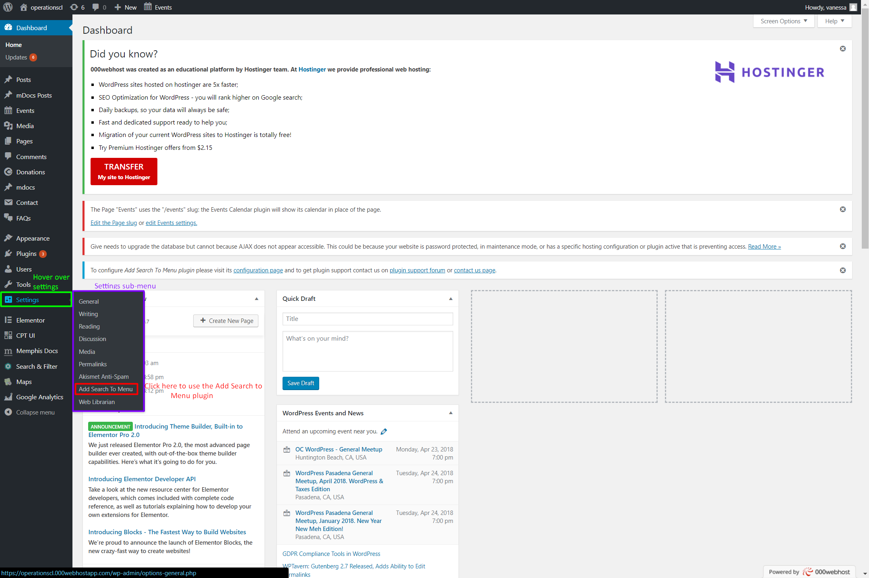

SearchMenuSS01

Adding Plugins to WordPress (cont.)

Configuration (cont.)

Add Search to Menu (cont.)

Choose the menus you'd like the search bar to be on and the post types you want the search bar to search through when used (SearchMenuSS02). Click on *Save Options* when done.

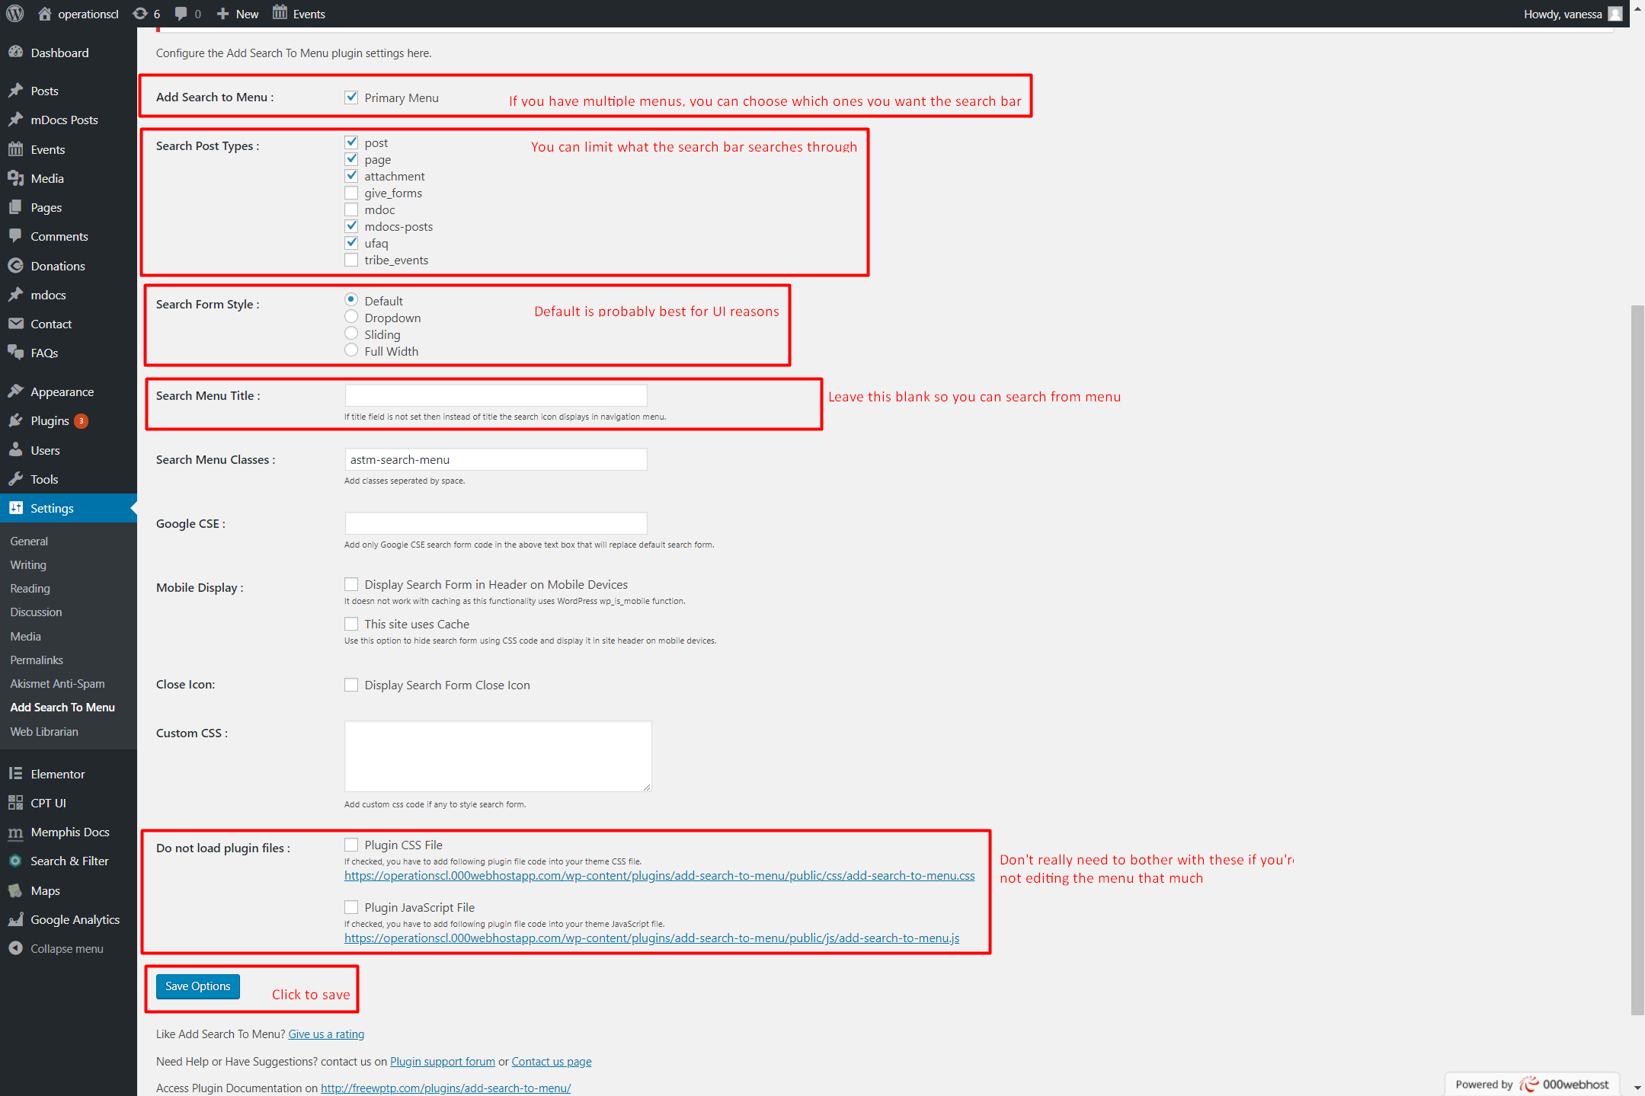  
SeachMenuSS02

Adding Plugins to WordPress (cont.)

Configuration (cont.)

### Contact Form 7

Plugin documentation from developers: [Click Here](https://contactform7.com/docs/)

#### Introduction

Forms are used for pages such as Space Rental, Volunteering Sign Up, Contact Us, etc. This is a how-to guide that goes through the steps taken to create a form using the plugin [Contact Form 7](https://wordpress.org/plugins/contact-form-7/).

#### Creating a form

When you are the WordPress admin dashboard, there should be a category on the left with the title Contact. When you hover your mouse over it, there should be three different options: Contact Forms, Add New, and Integration. Click on Add New. There should now be a default form in front of you with basic form fields created. Customize as you wish by creating a title, click on buttons to create the fields you desire, and going through the other tabs to meet your needs. Click Save when you're done.

After creating a form, hover over Contact again and this time click on Contact Forms. This will take you to a page that lists out all the forms you've created. When you find the name of the form you just created, you'll see there's a middle column named Shortcode. Copy the shortcode of your form. Next, hover your mouse over Pages on the left hand menu. Click on Add New to create a new page. In the body of the page, paste the shortcode in. This page will now have the form you just created. Customize the page to meet your needs.

Adding Plugins to WordPress (cont.)

Configuration (cont.)

### Event Organizer

Plugin documentation from developers: [Click Here](http://docs.wp-event-organiser.com/)

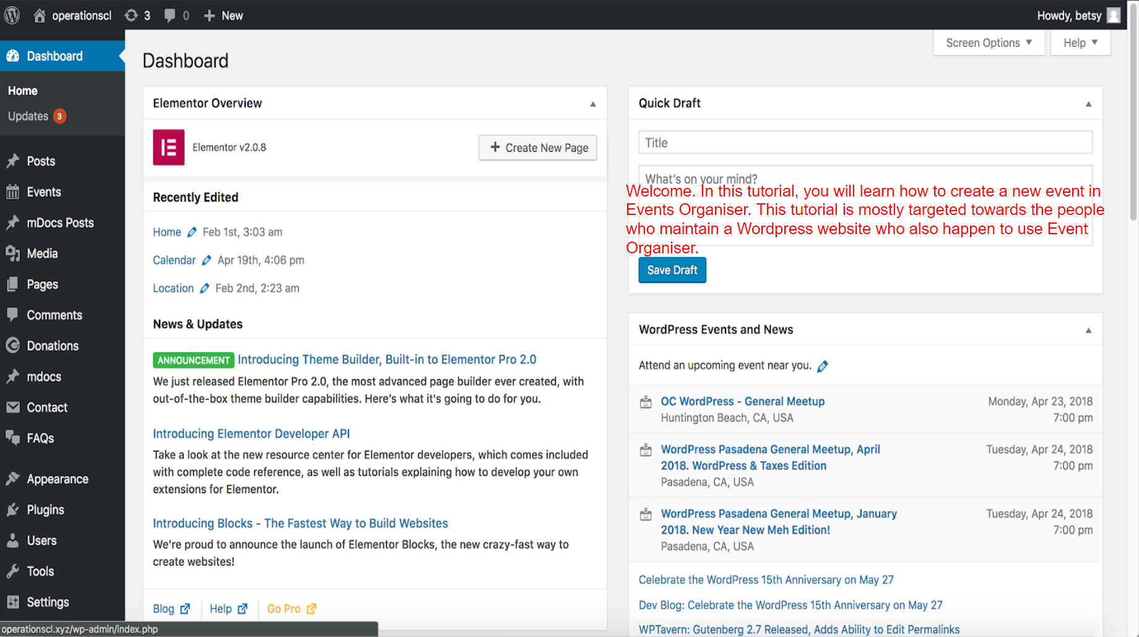

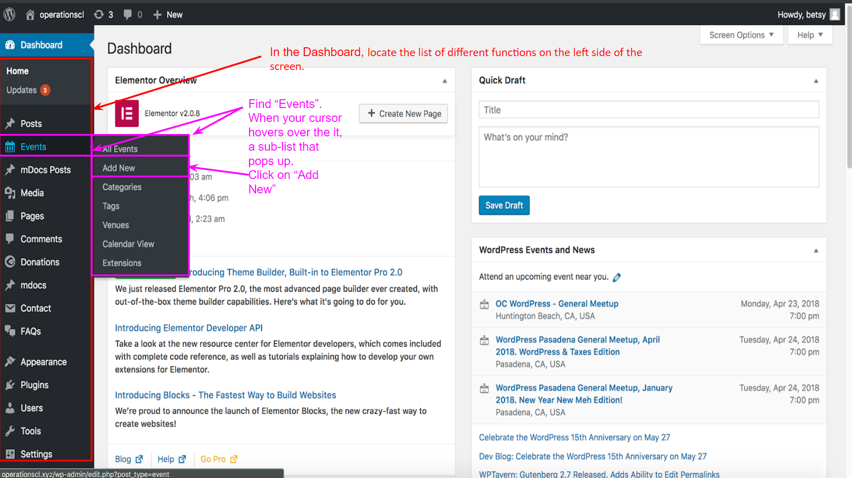

Adding Plugins to WordPress (cont.)

Configuration (cont.)

Event Organizer (cont.)

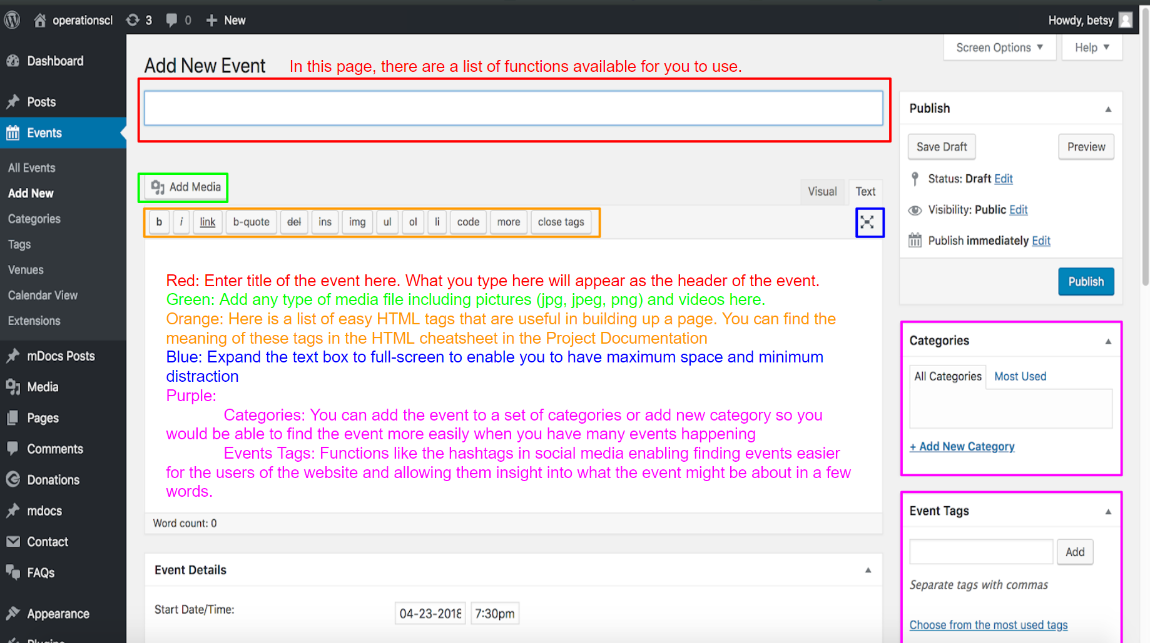

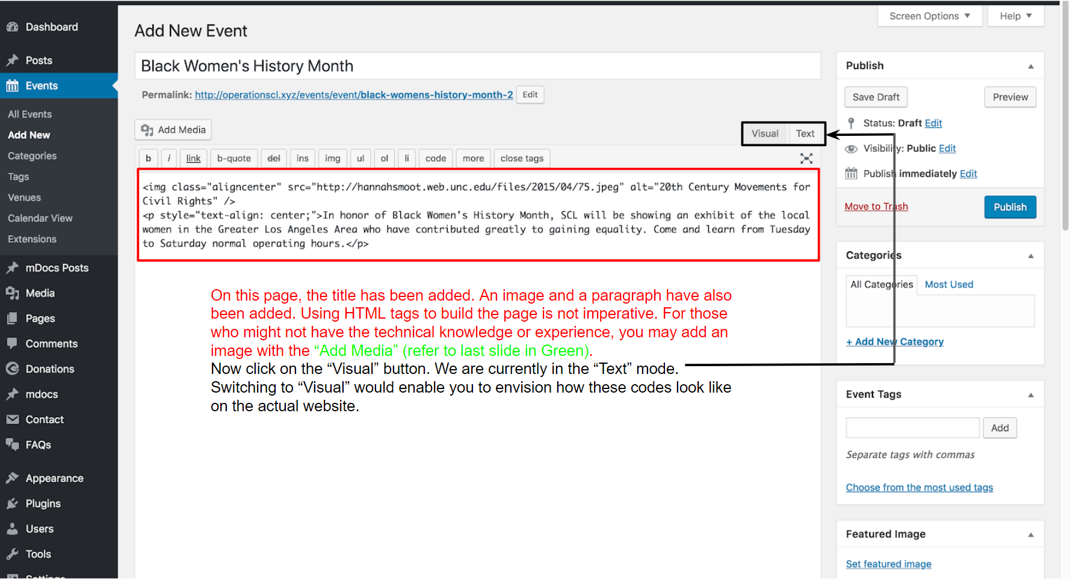

Adding Plugins to WordPress (cont.)

Configuration (cont.)

Event Organizer (cont.)

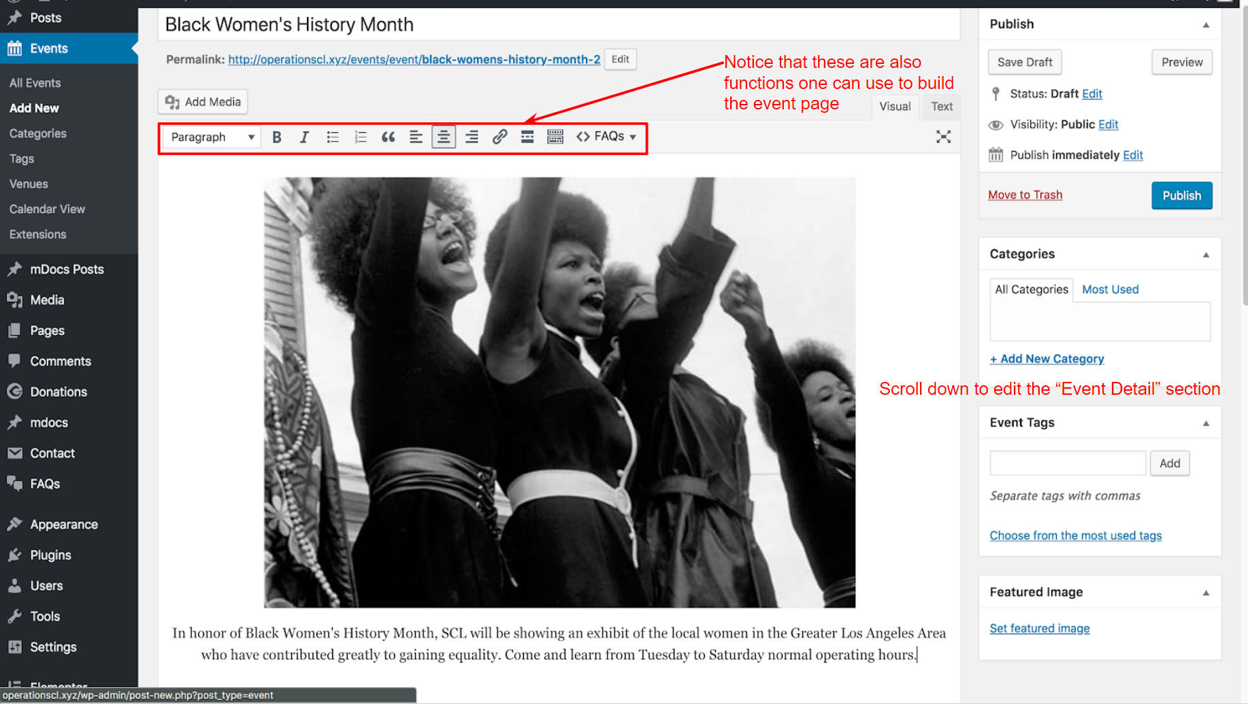

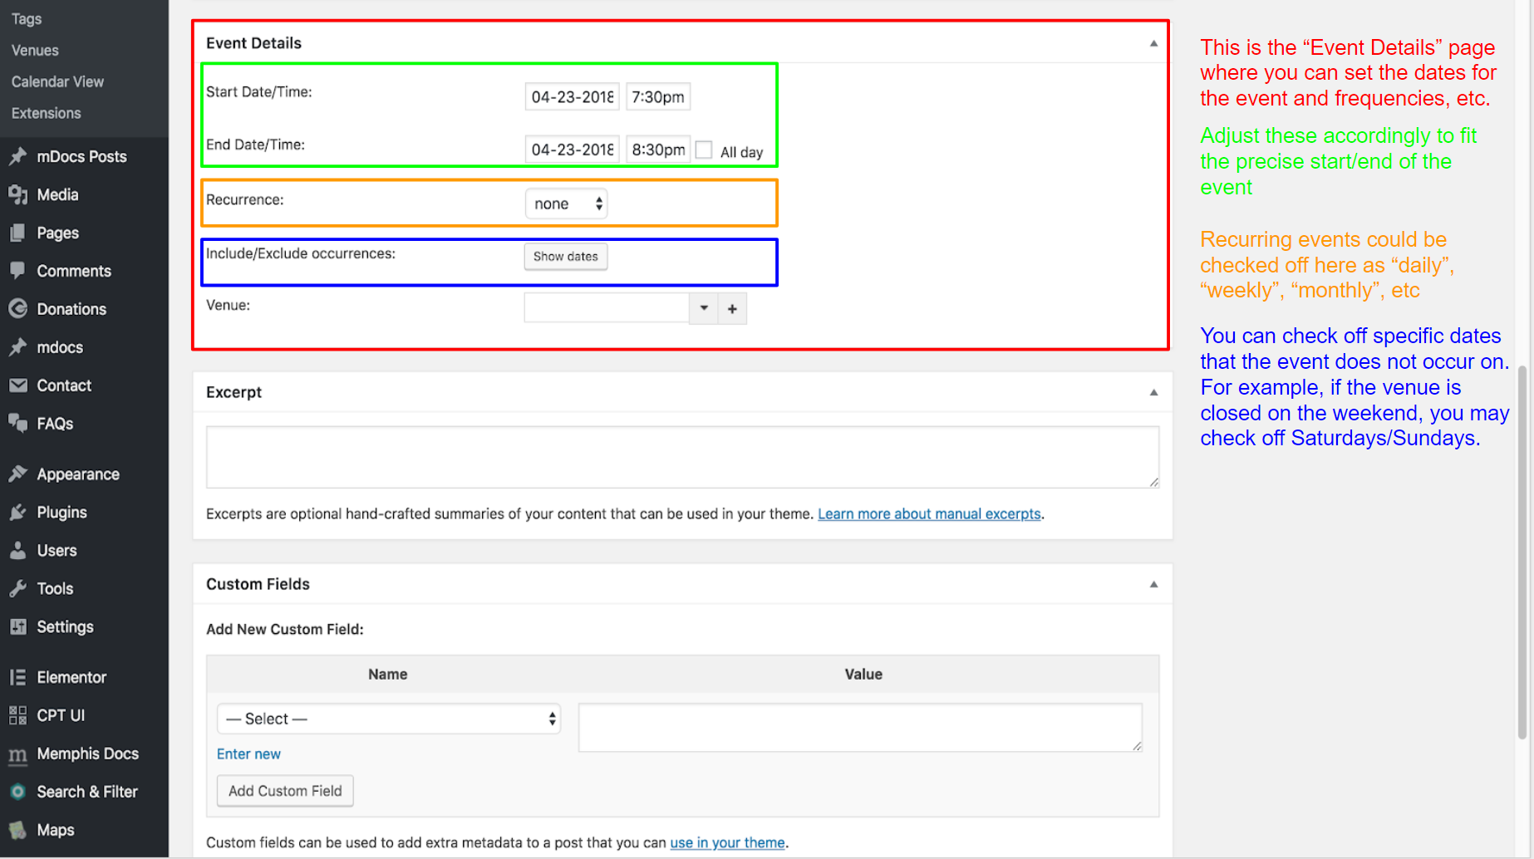

Adding Plugins to WordPress (cont.)

Configuration (cont.)

Event Organizer (cont.)

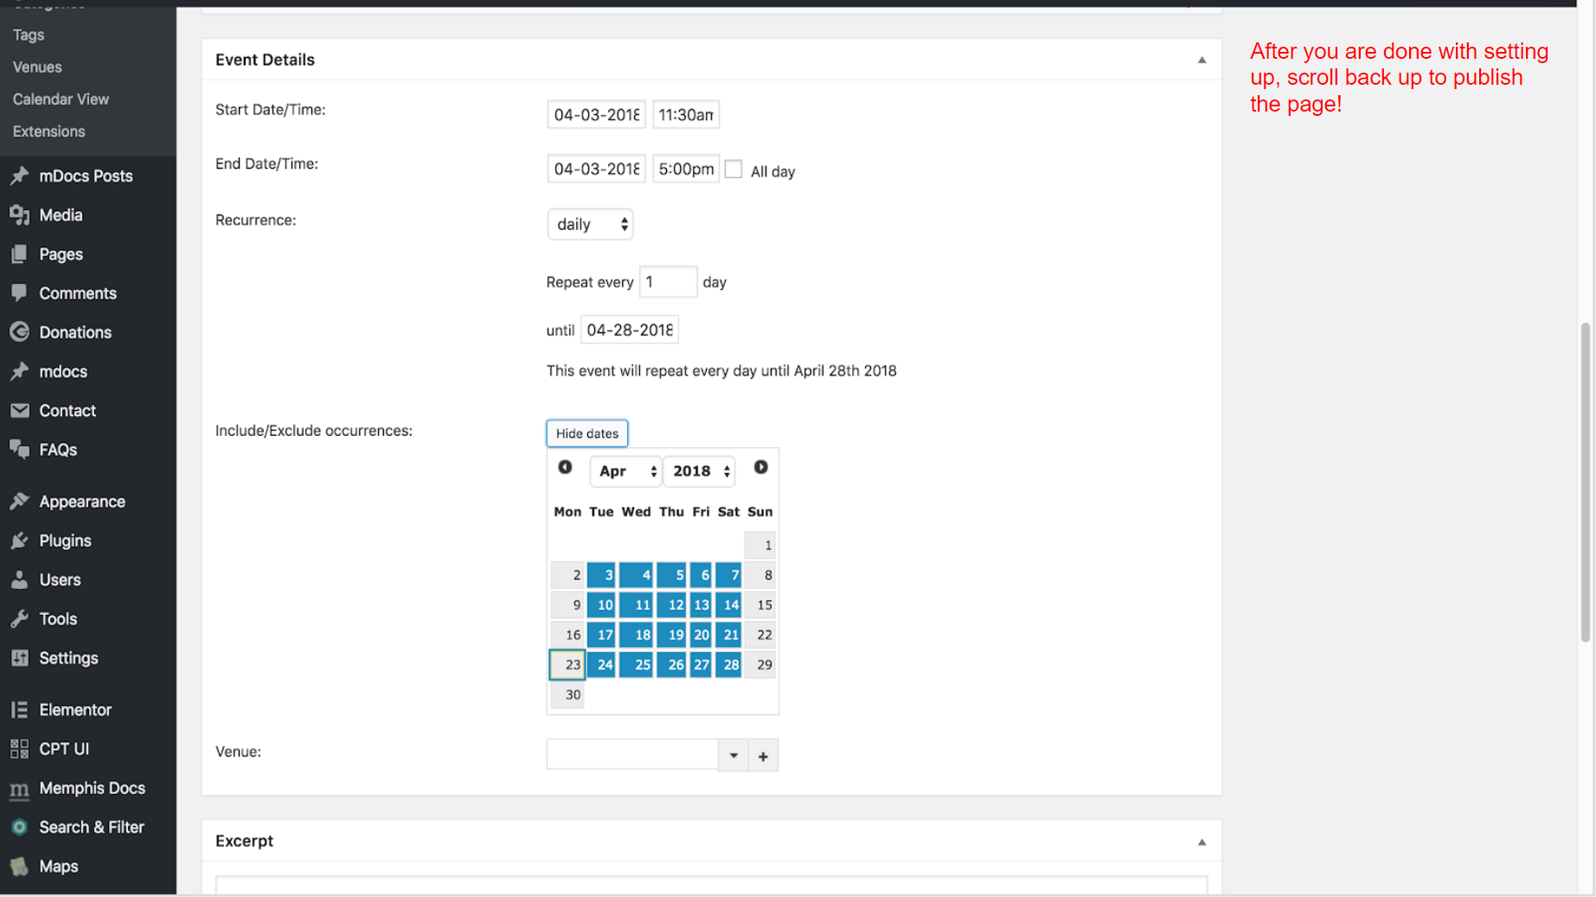

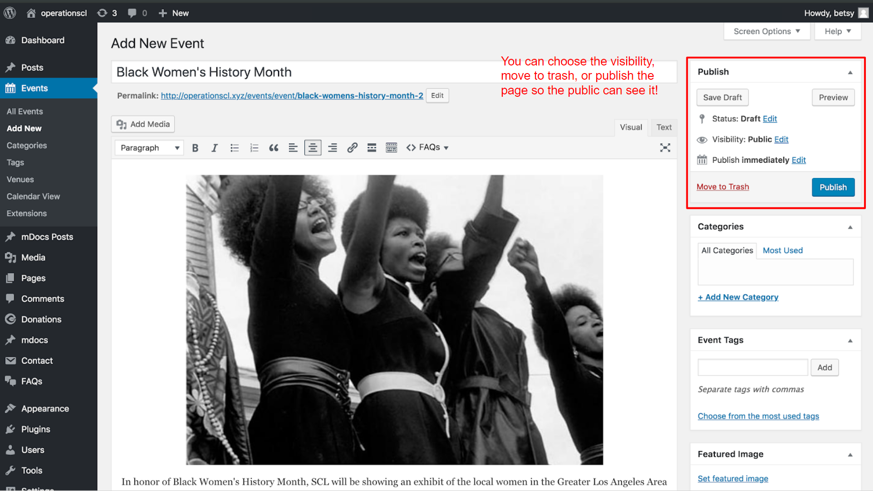

Adding Plugins to WordPress (cont.)

Configuration (cont.)

### Give Donation

Plugin documentation from developers: [Click Here](https://givewp.com/documentation/)

Go to the Give tab of your WordPress dashboard by clicking on *Donations*(GiveSS01).

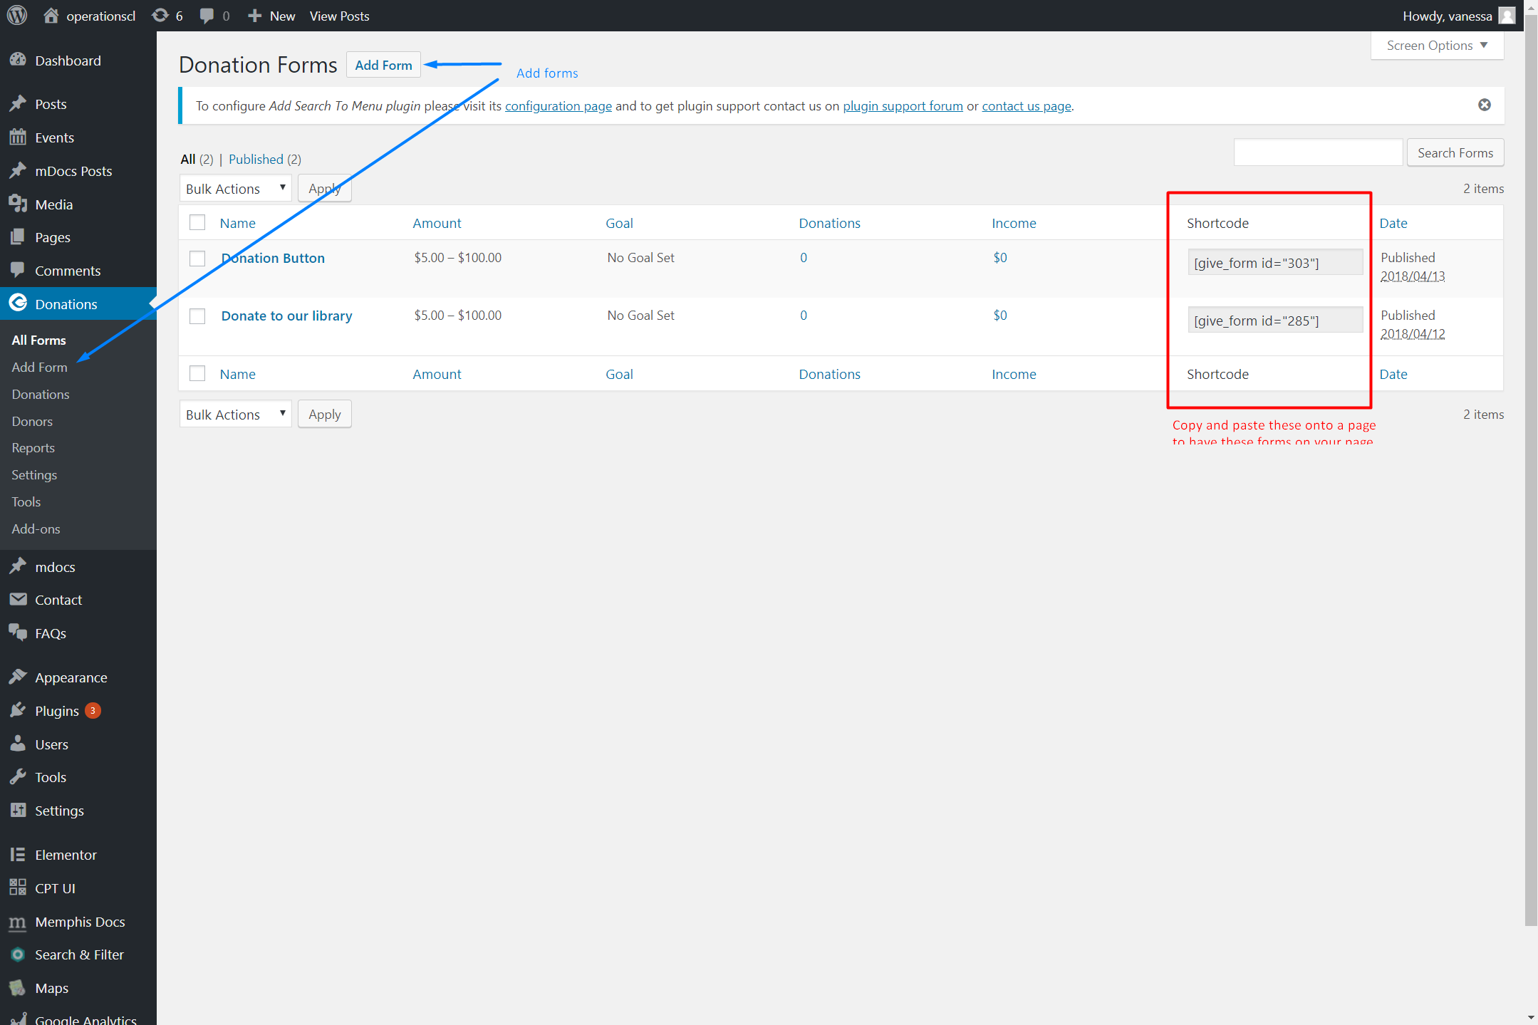

GiveSS01

Adding Plugins to WordPress (cont.)

Configuration (cont.)

Give Donation (cont.)

You can edit and make your form with the settings provided (GiveSS02). Once you have made your first form, go to the *Settings* tab of your Give plugin (GiveSS02). Make sure to click *Save changes* after every change.

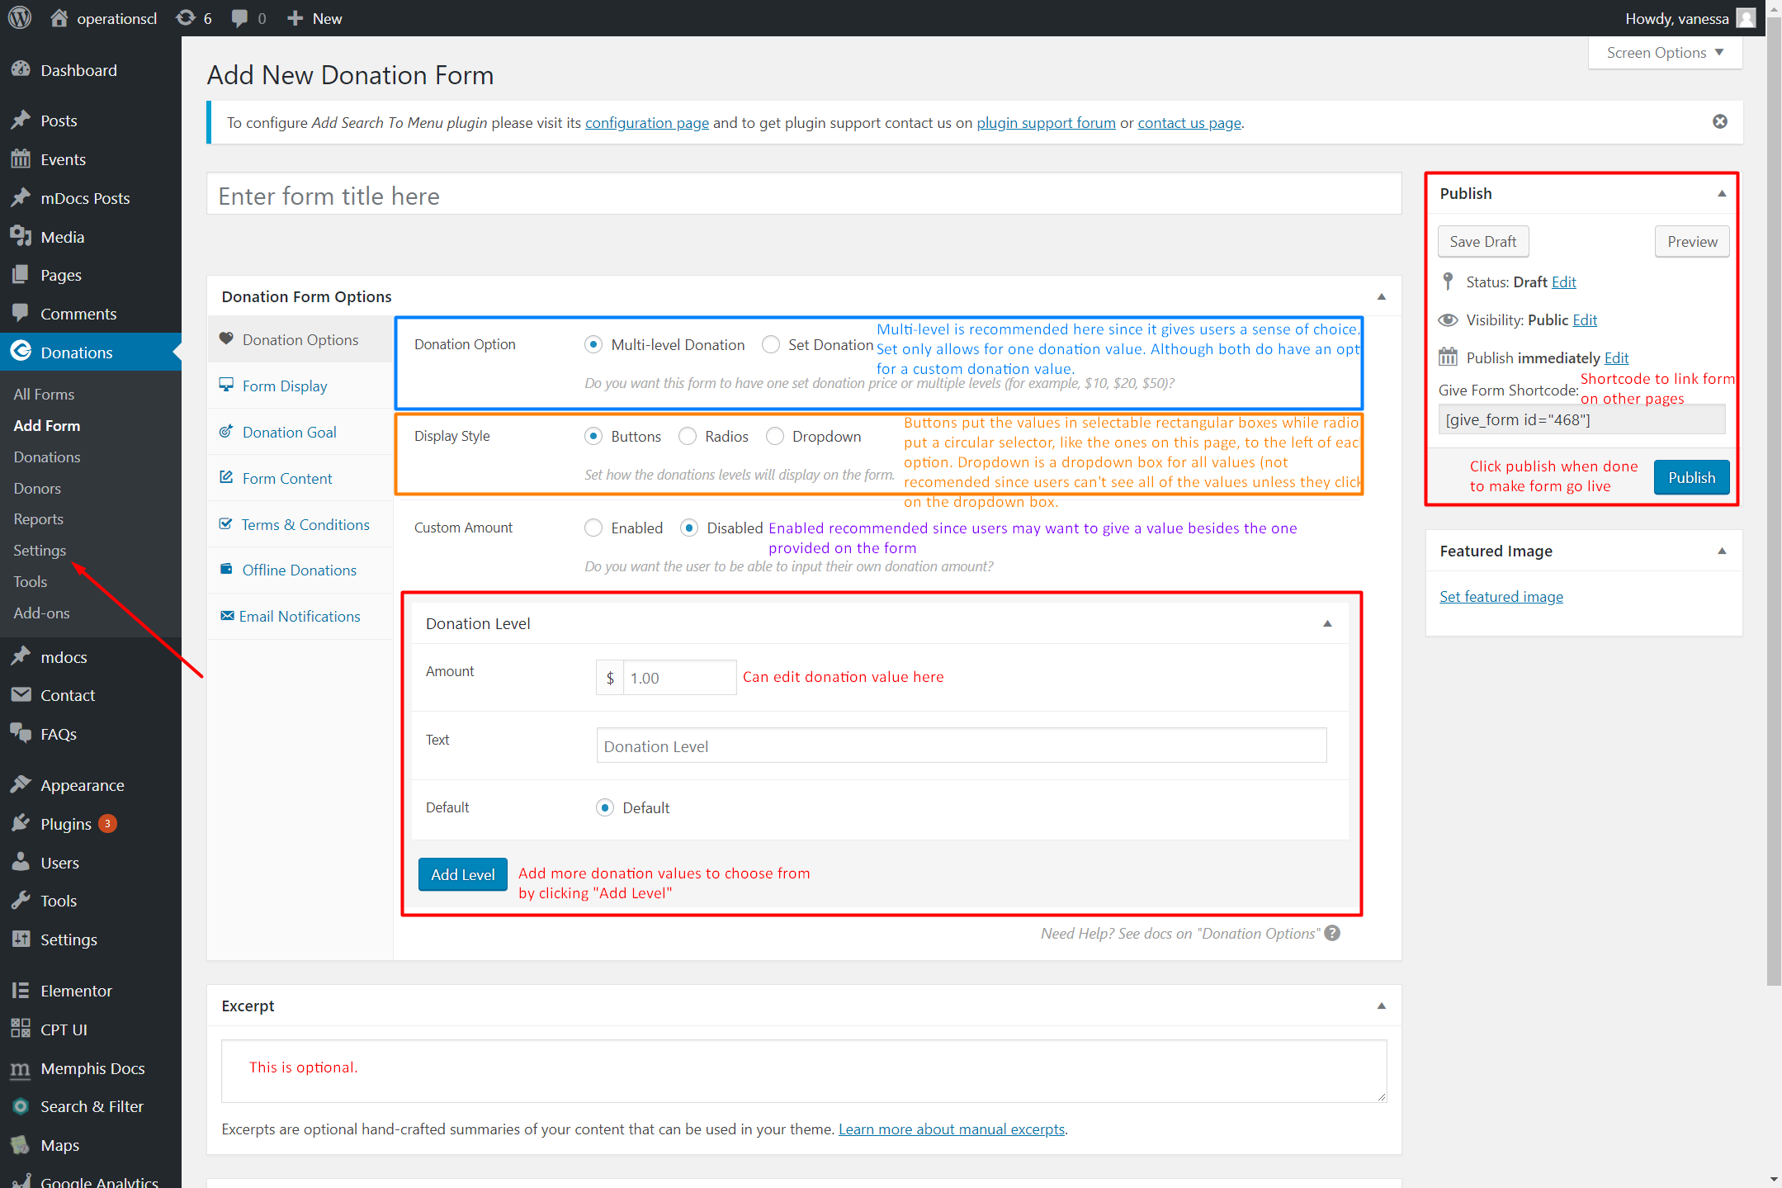

GiveSS02

Adding Plugins to WordPress (cont.)

Configuration (cont.)

Give Donation (cont.)

The first page tells you what additional pages you need to make on WordPress for your plugin (GiveSS03). It will also give you the minimum content needed on each page.

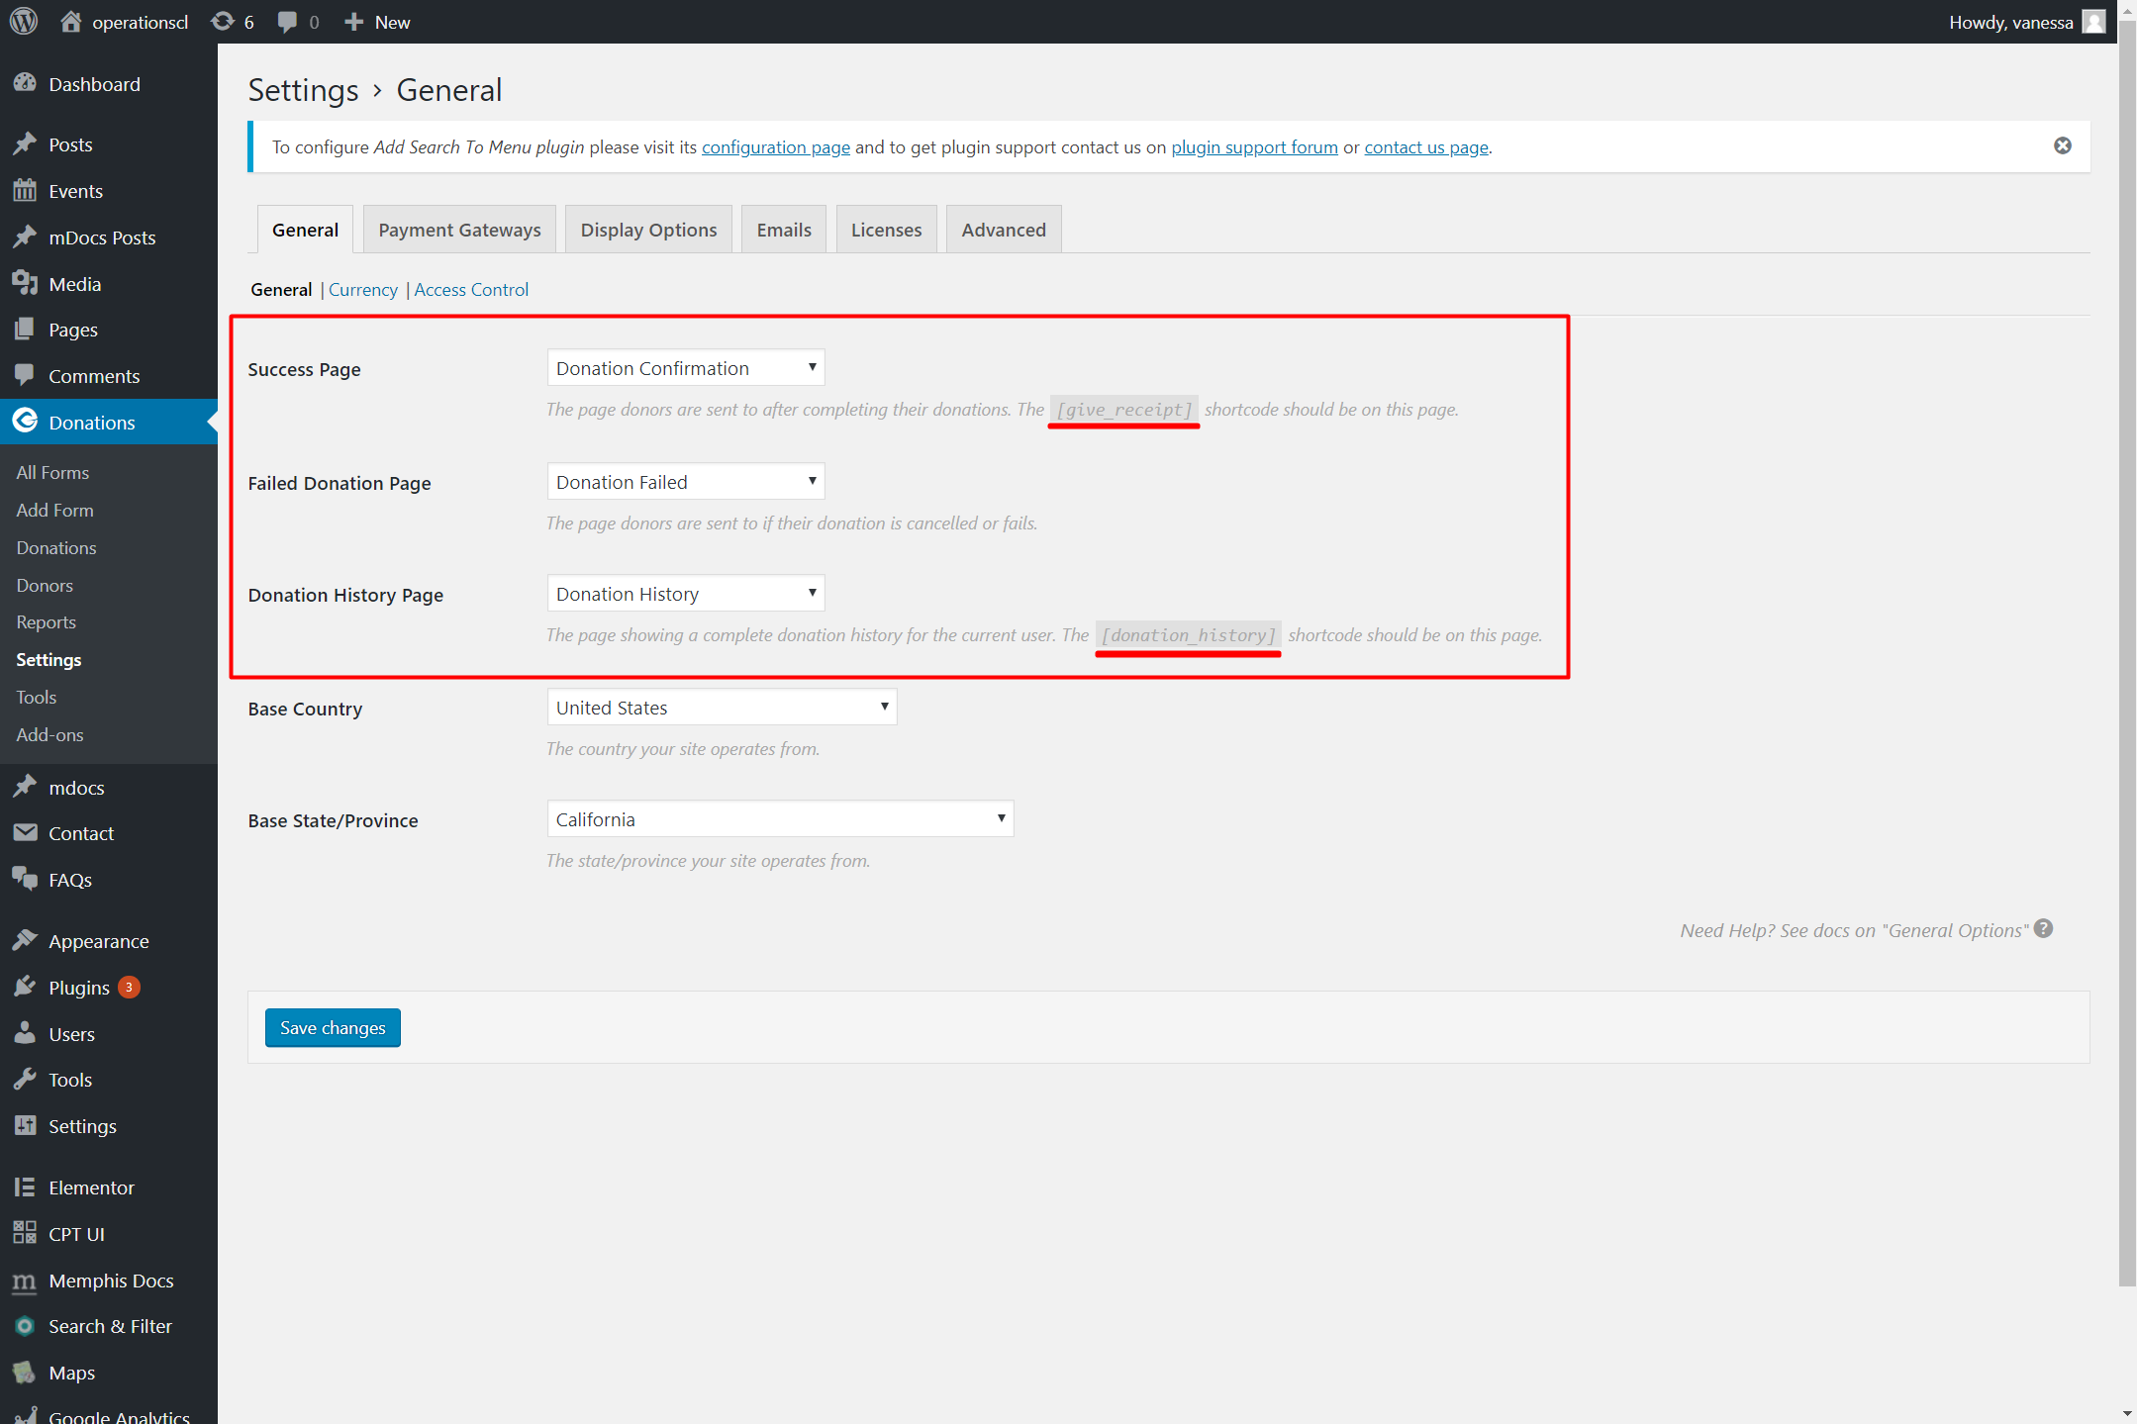

GiveSS03

Adding Plugins to WordPress (cont.)

Configuration (cont.)

Give Donation (cont.)

Going to the *Payment Gateways* tab will allow you to turn test donations on and off (GiveSS04.png).

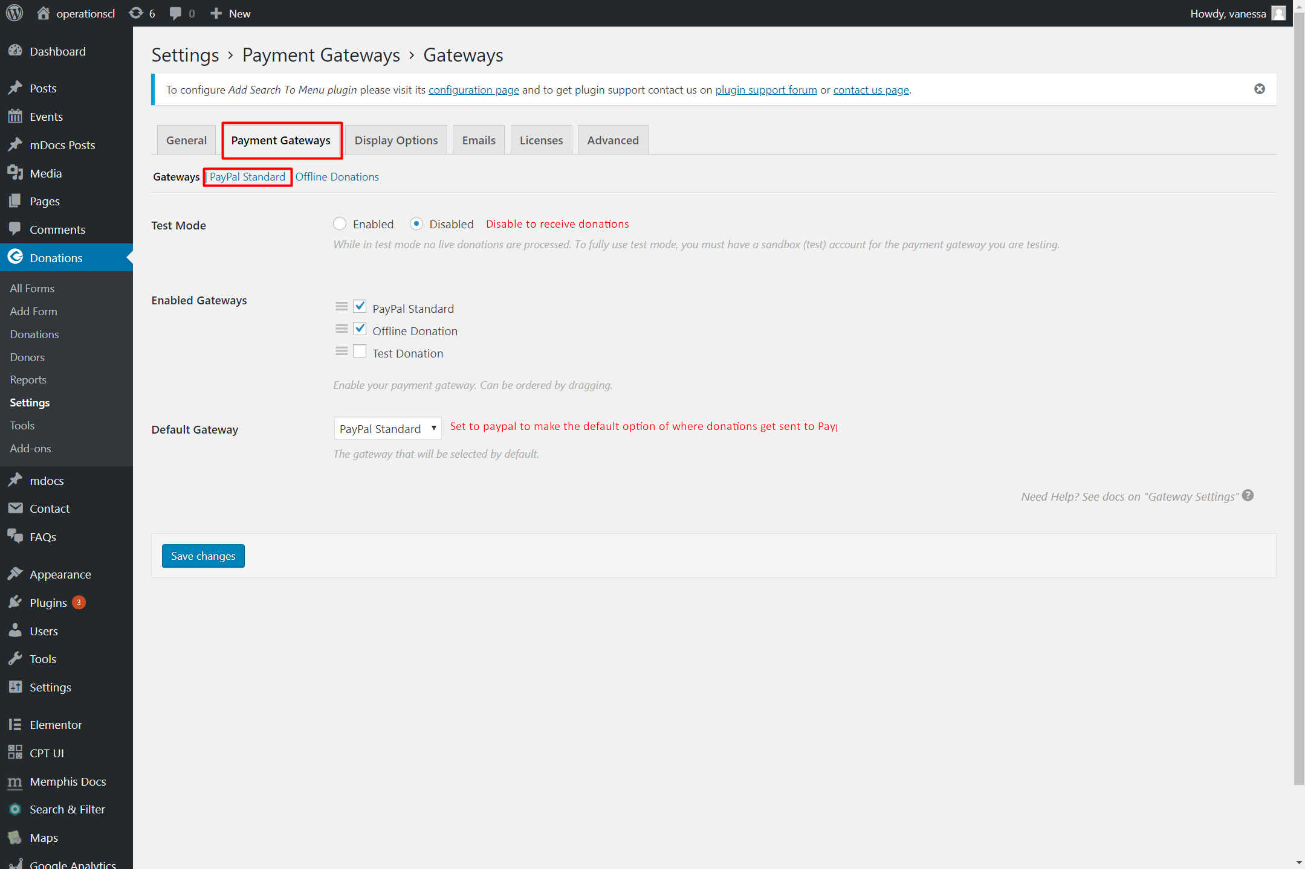

GiveSS04

Adding Plugins to WordPress (cont.)

Configuration (cont.)

Give Donation (cont.)

The *PayPal Standard* tab is where you can input information about which PayPal account to send the money to (GiveSS05).

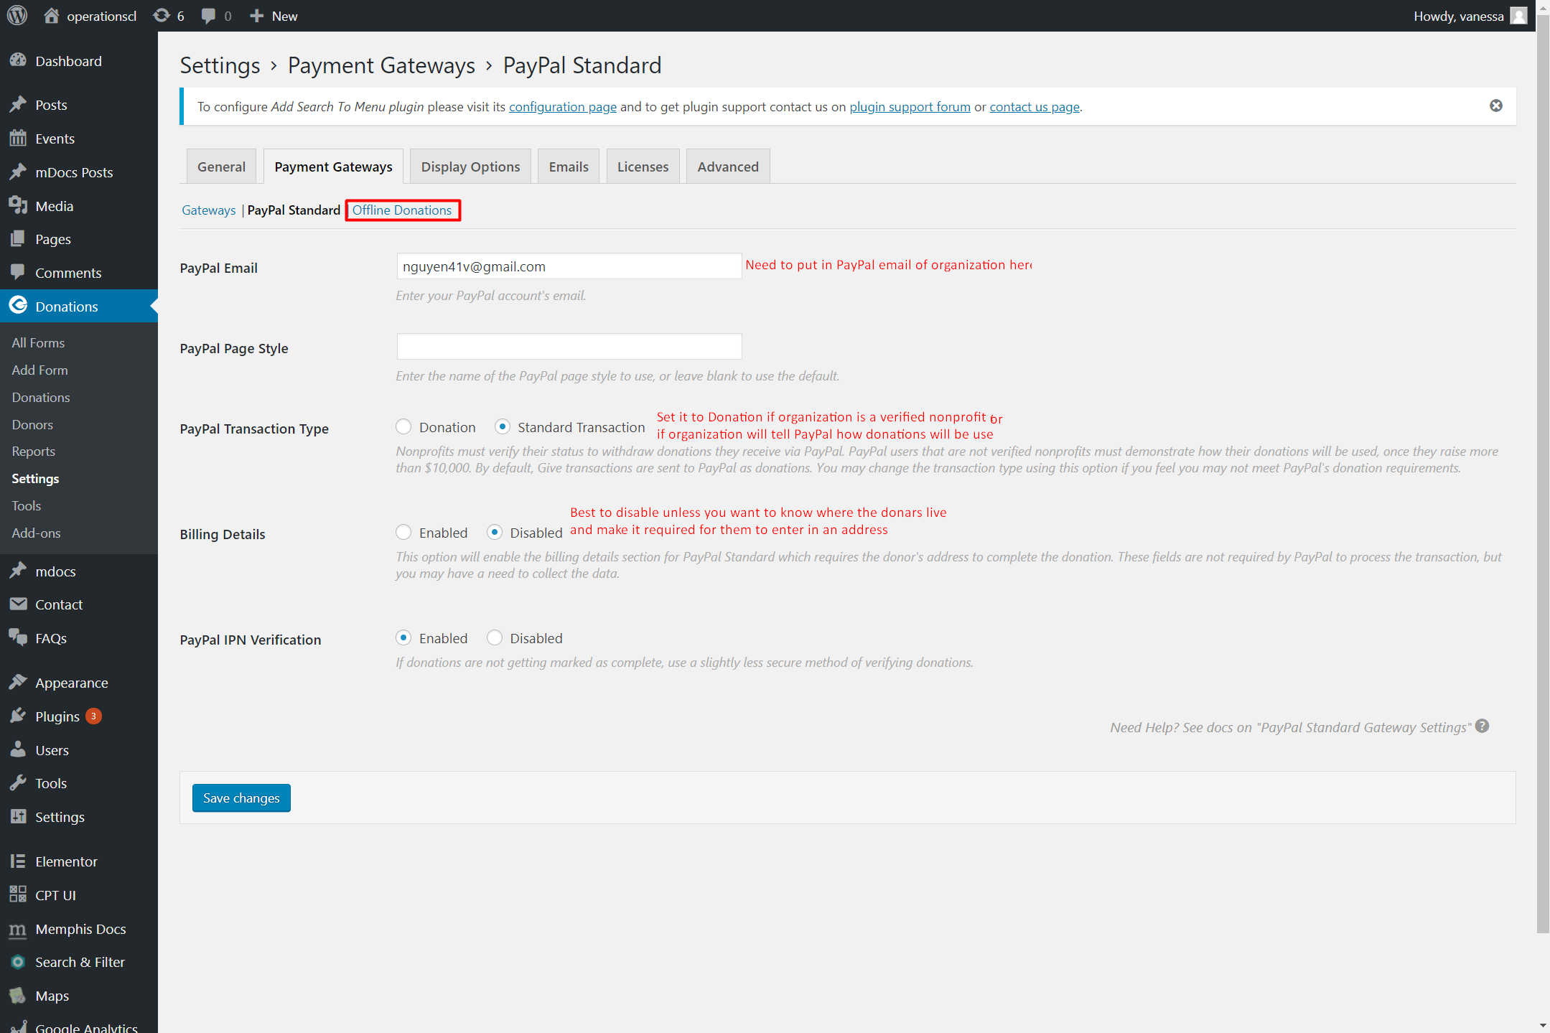

GiveSS05

Adding Plugins to WordPress (cont.)

Configuration (cont.)

Give Donation (cont.)

The *Offline Donations* tab is where you can edit the message to give to donors if they want to mail in donations instead (GiveSS06).

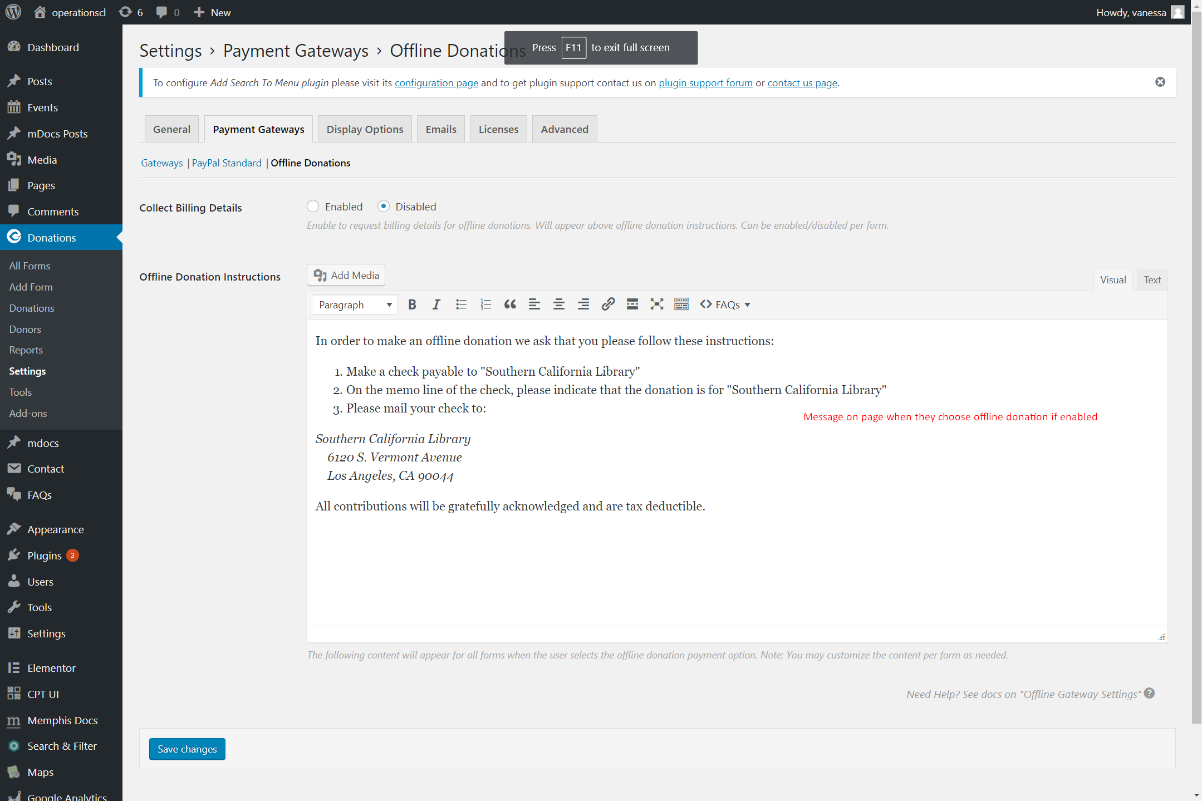

GiveSS06

Adding Plugins to WordPress (cont.)

Configuration (cont.)

### Google Analytics

Plugin documentation from developers: [Click Here](https://deconf.com/)

Adding Plugins to WordPress (cont.)

Configuration (cont.)

### Memphis Documents

#### Adding and moving folders

Plugin documentation from developers: [Click Here](https://wordpress.org/plugins/memphis-documents-library/) (no documentation found but there is a support form and FAQ on here)

Once you have the Memphis Documents Library plugin activated, there should be a button for it on the side called *Memphis Docs* (MemphisSS01).

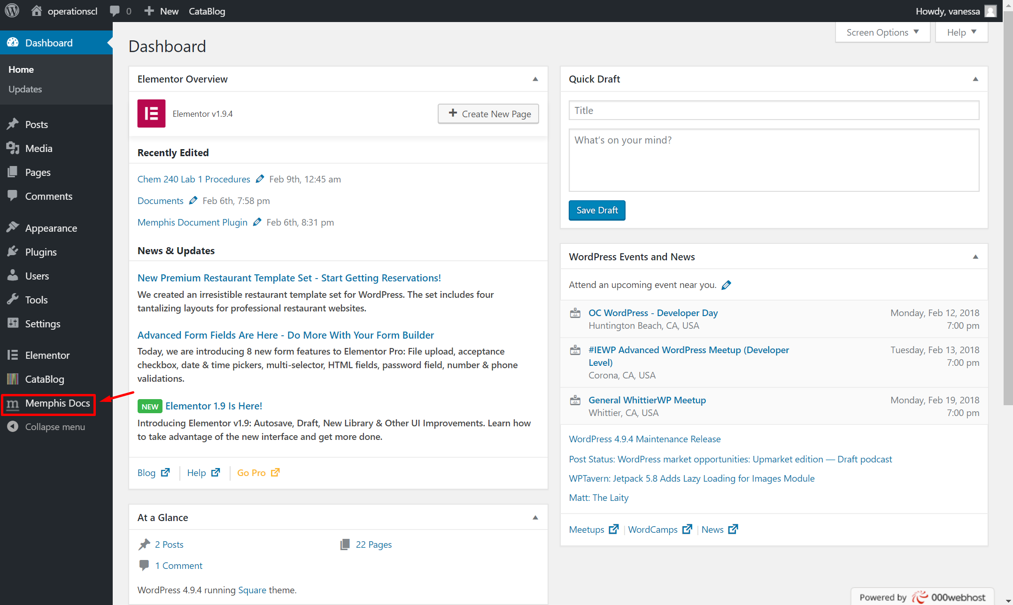

MemphisSS01

Adding Plugins to WordPress (cont.)

Configuration (cont.)

Memphis Documents (cont.)

*Adding and moving folders (cont.)*

Click on it and then click on *Options* (MemphisSS02).

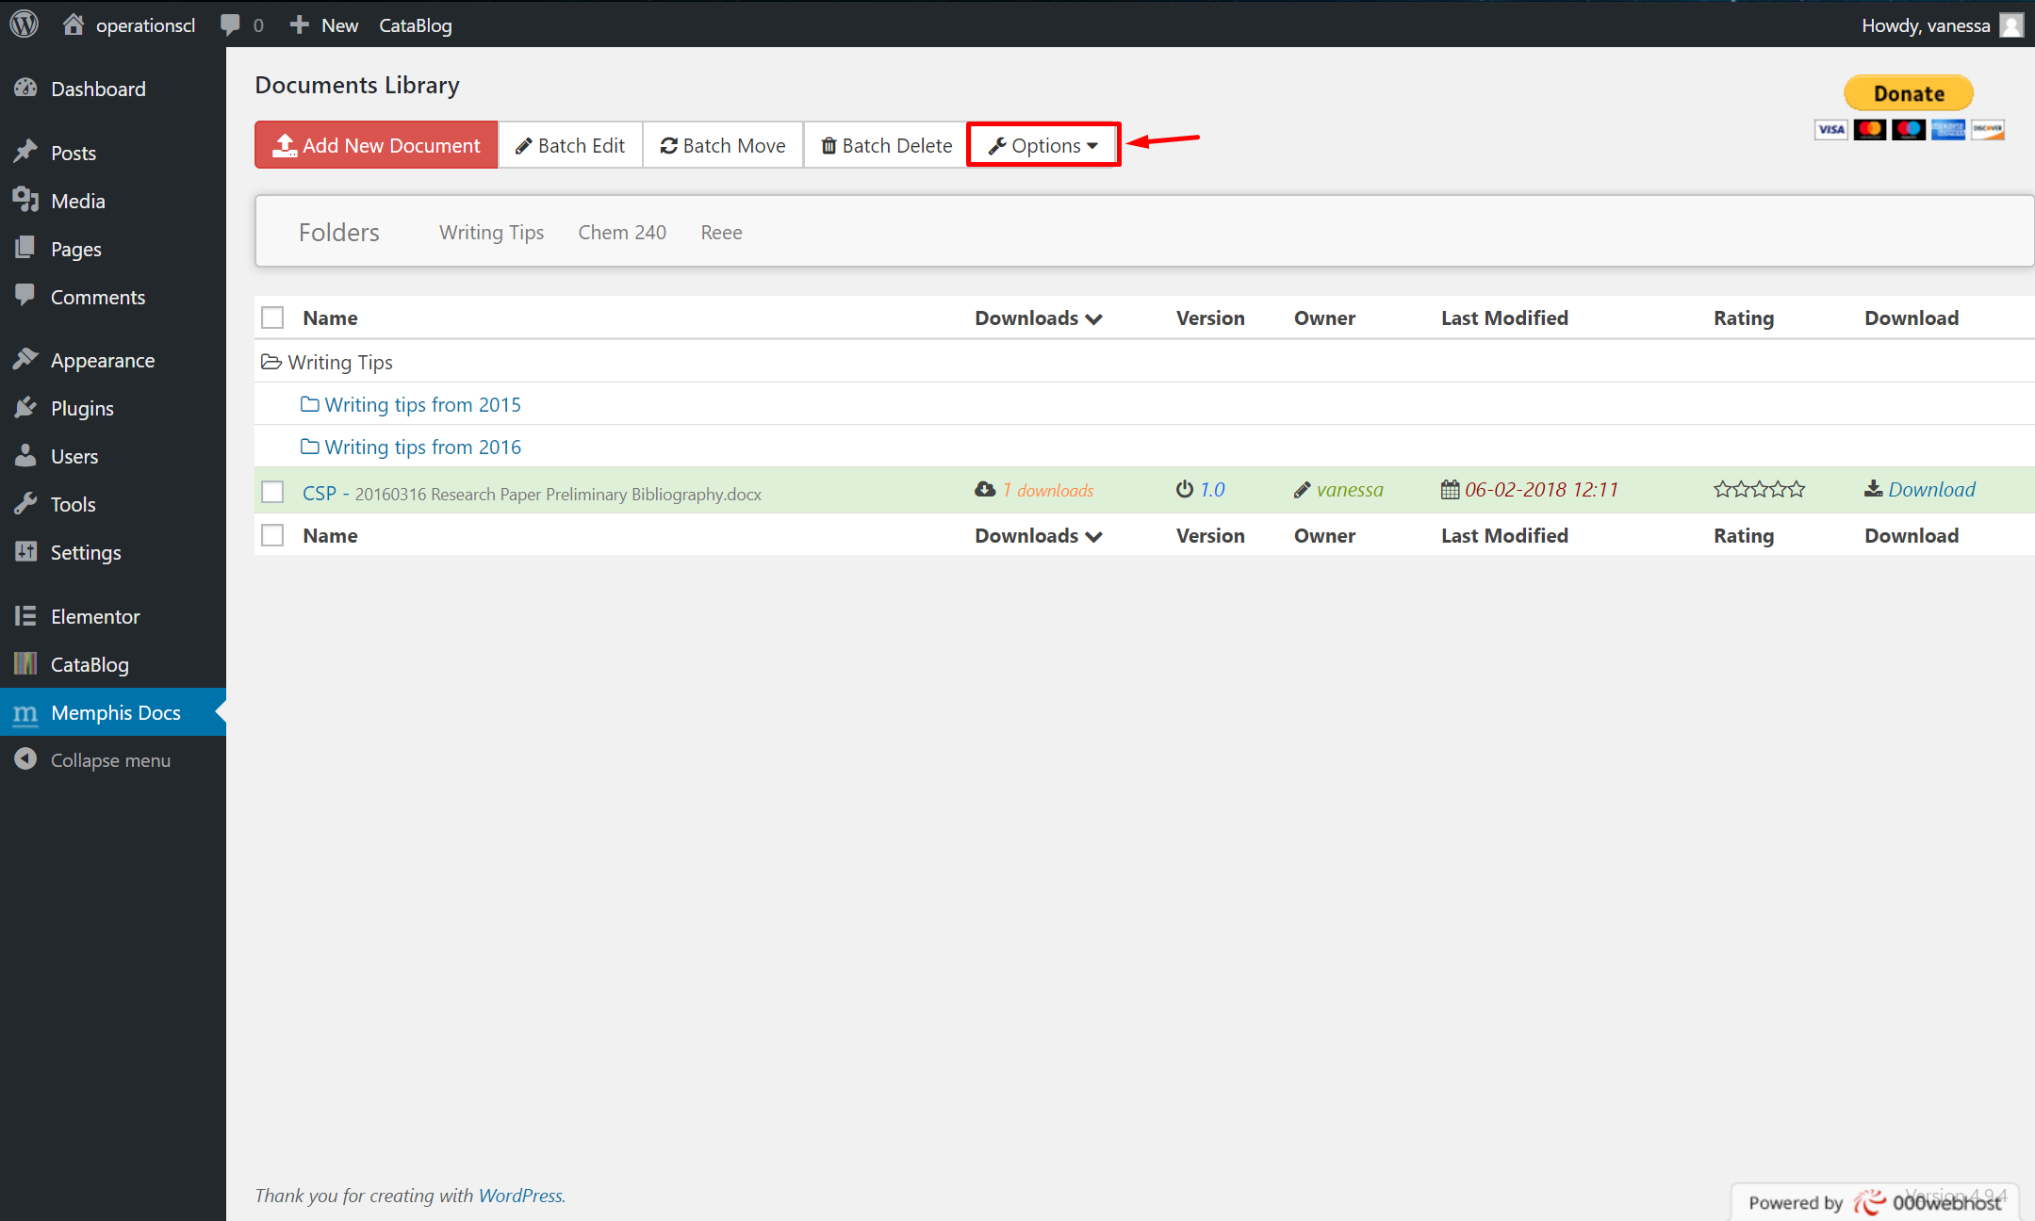

MemphisSS02

Adding Plugins to WordPress (cont.)

Configuration (cont.)

Memphis Documents (cont.)

*Adding and moving folders (cont.)*

Then click *Edit Folders* (MemphisSS03).

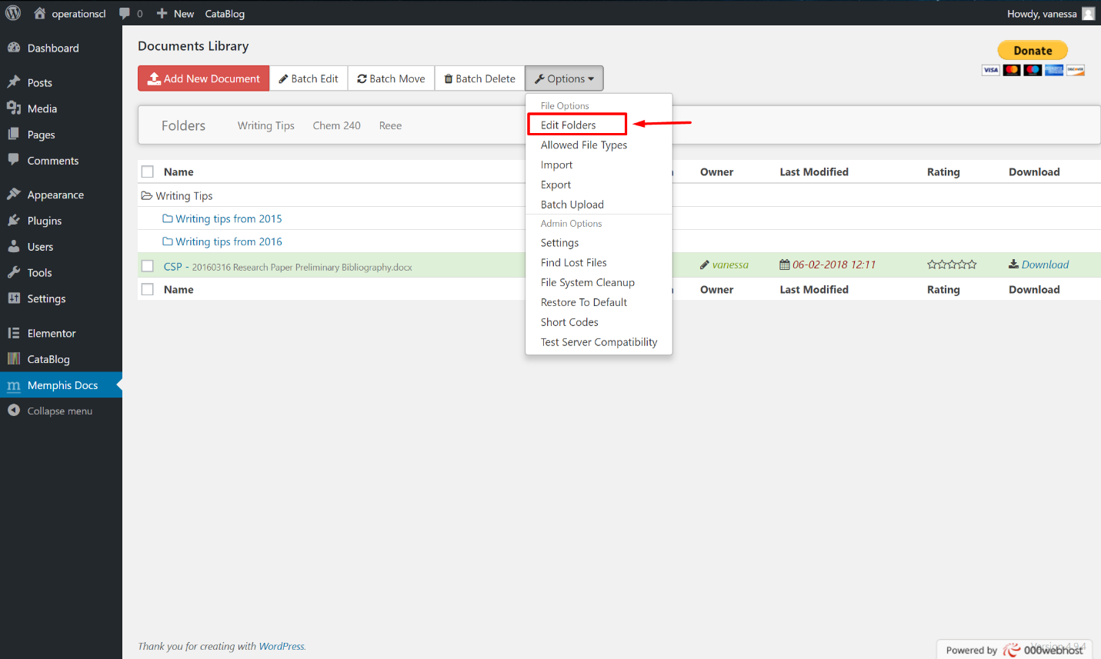

MemphisSS03

Adding Plugins to WordPress (cont.)

Configuration (cont.)

Memphis Documents (cont.)

*Adding and moving folders (cont.)*

There are several options here. You can add a main folder with the *Add Main Folder* button which will appear at the top of the plugin (MemphisSS04).

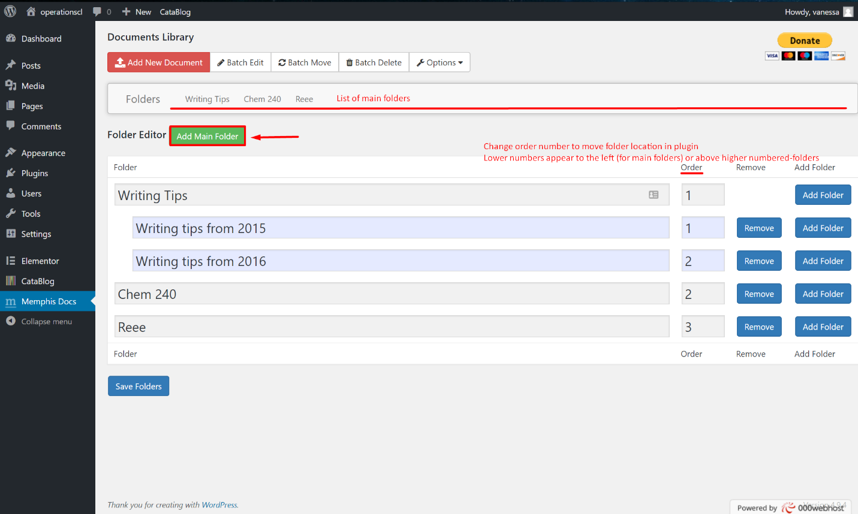

MemphisSS04

Adding Plugins to WordPress (cont.)

Configuration (cont.)

Memphis Documents (cont.)

*Adding and moving folders (cont.)*

You can also add subfolders of other folders with the *Add Folder* button (MemphisSS05). Once you add a folder, you can name it and you can also change the order number (MemphisSS04).

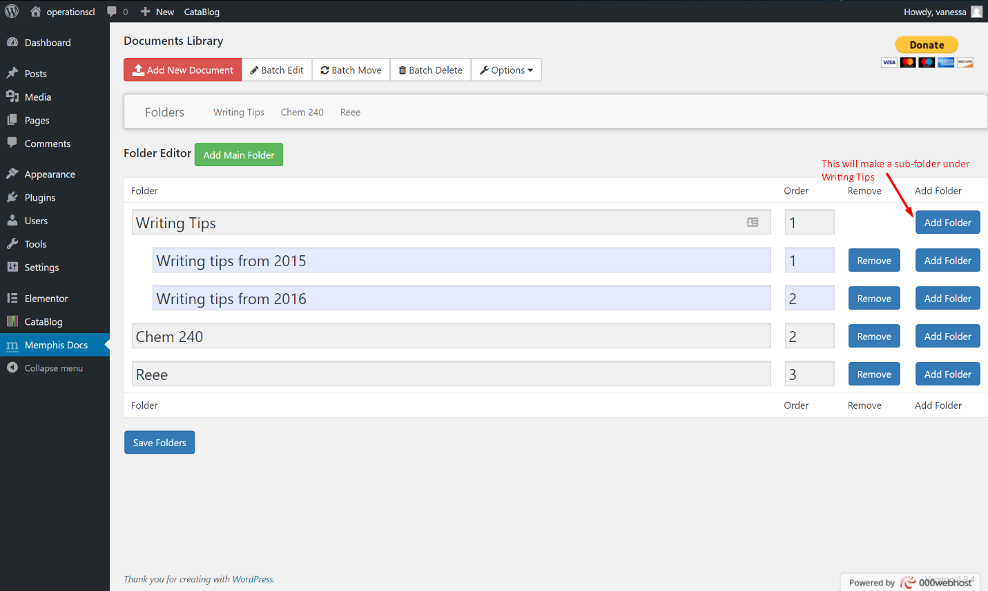

MemphisSS05

Adding Plugins to WordPress (cont.)

Configuration (cont.)

Memphis Documents (cont.)

*Adding and moving folders (cont.)*

Changing the order number will change the folder's location relative to other folders in the same level as it. Once you are done editing your folders, click *Save Folders* (MemphisSS06).

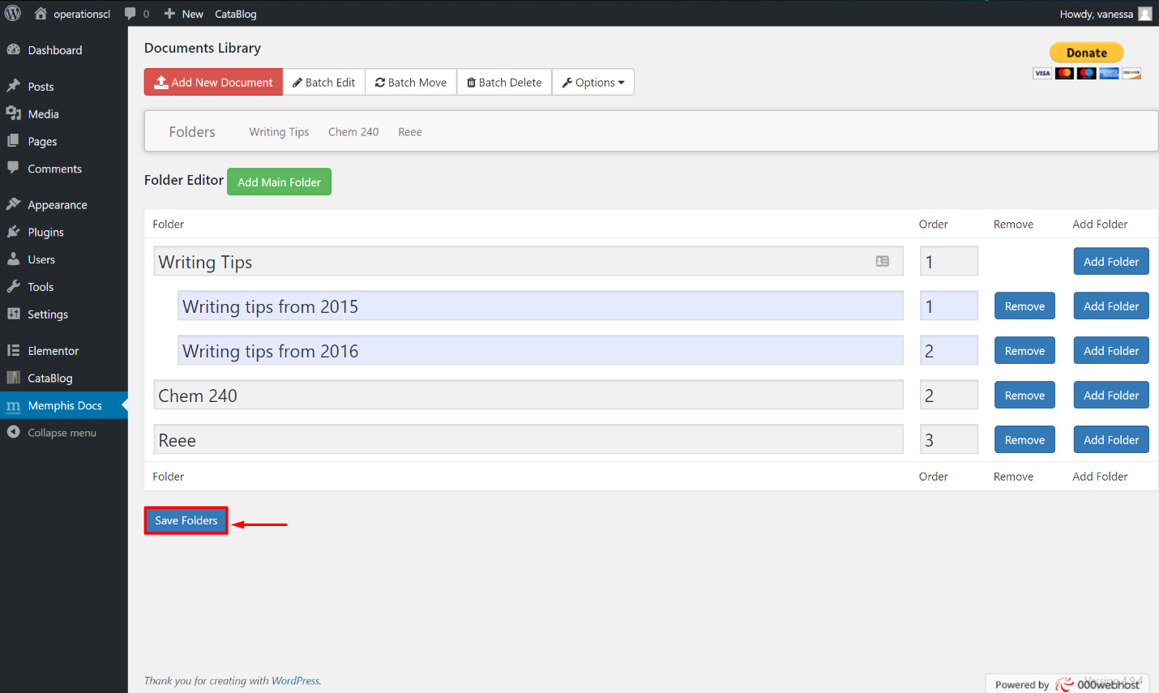

MemphisSS06

Adding Plugins to WordPress (cont.)

Configuration (cont.)

Memphis Documents (cont.)

#### Adding a new document

Under the Memphis Documents Library plugin, there is an *Add New Document* button to the upper left (MemphisSS07).

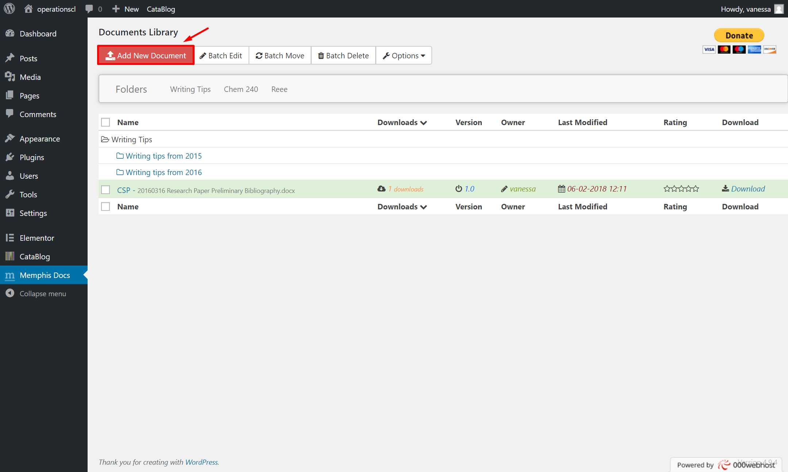

MemphisSS07

Adding Plugins to WordPress (cont.)

Configuration (cont.)

Memphis Documents (cont.)

*Adding a new document (cont.)*

Once you click on it, you can name the file, choose where you want the file to be in your online library, give it tags or categories. Click on the *Choose File* button to choose the document you want to upload (MemphisSS08).

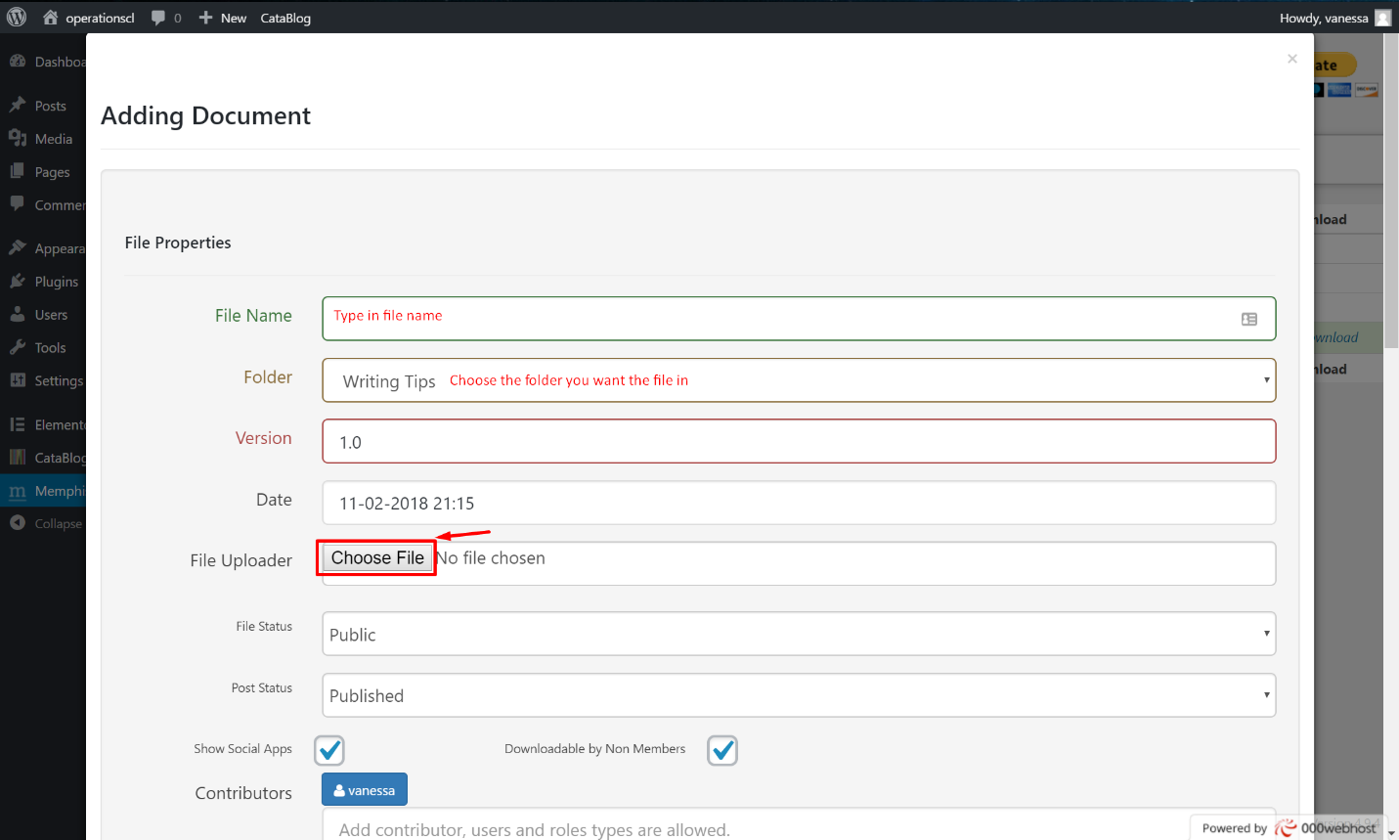

MemphisSS08

Adding Plugins to WordPress (cont.)

Configuration (cont.)

Memphis Documents (cont.)

*Adding a new document (cont.)*

Once you chose your file you can upload it by clicking on *Add Document* at the bottom left (MemphisSS09).

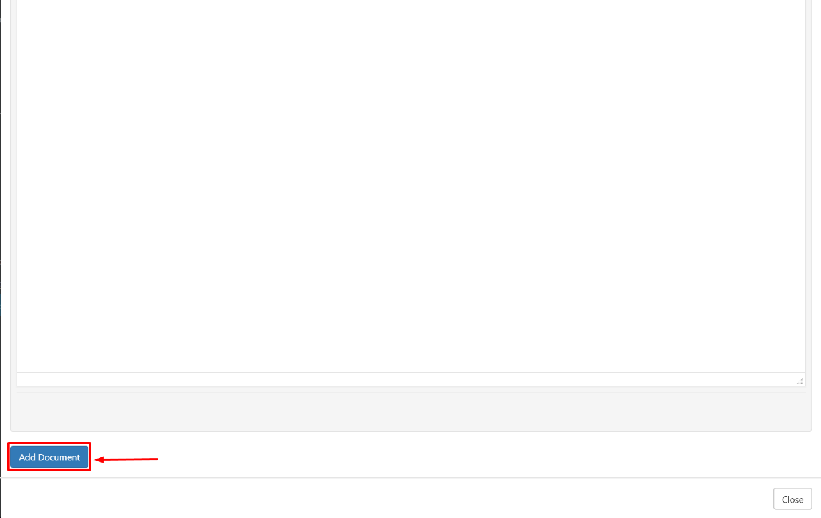

MemphisSS09

Adding Plugins to WordPress (cont.)

Configuration (cont.)

Memphis Documents (cont.)

#### Adding multiple documents at once with a ZIP file

Under the Memphis Documents Library plugin, click on *Options* (MemphisSS10.png).

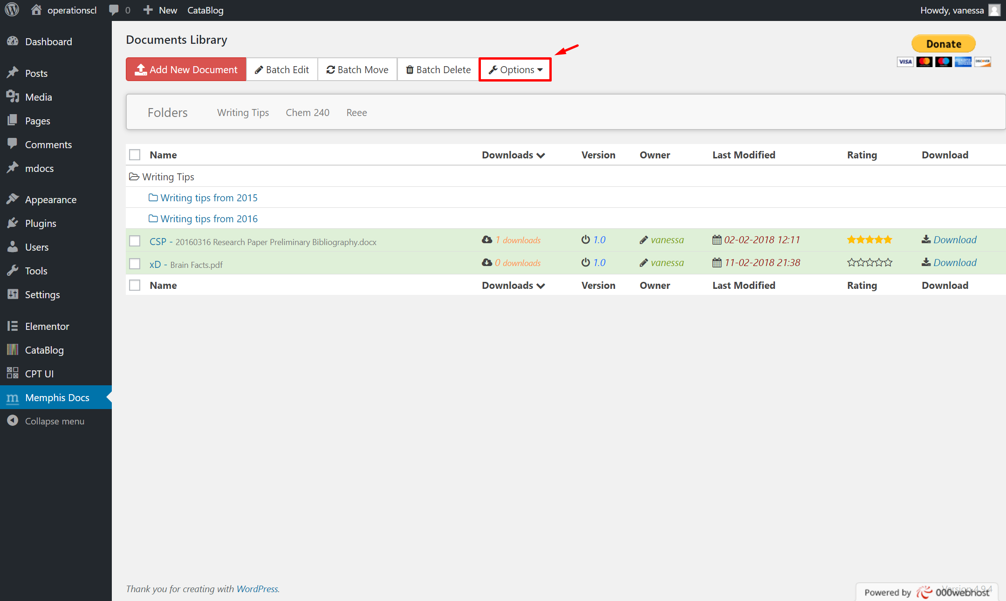

MemphisSS10

Adding Plugins to WordPress (cont.)

Configuration (cont.)

Memphis Documents (cont.)

*Adding multiple documents at once with a ZIP file (cont.)*

Then click *Batch Upload* (MemphisSS11.png).

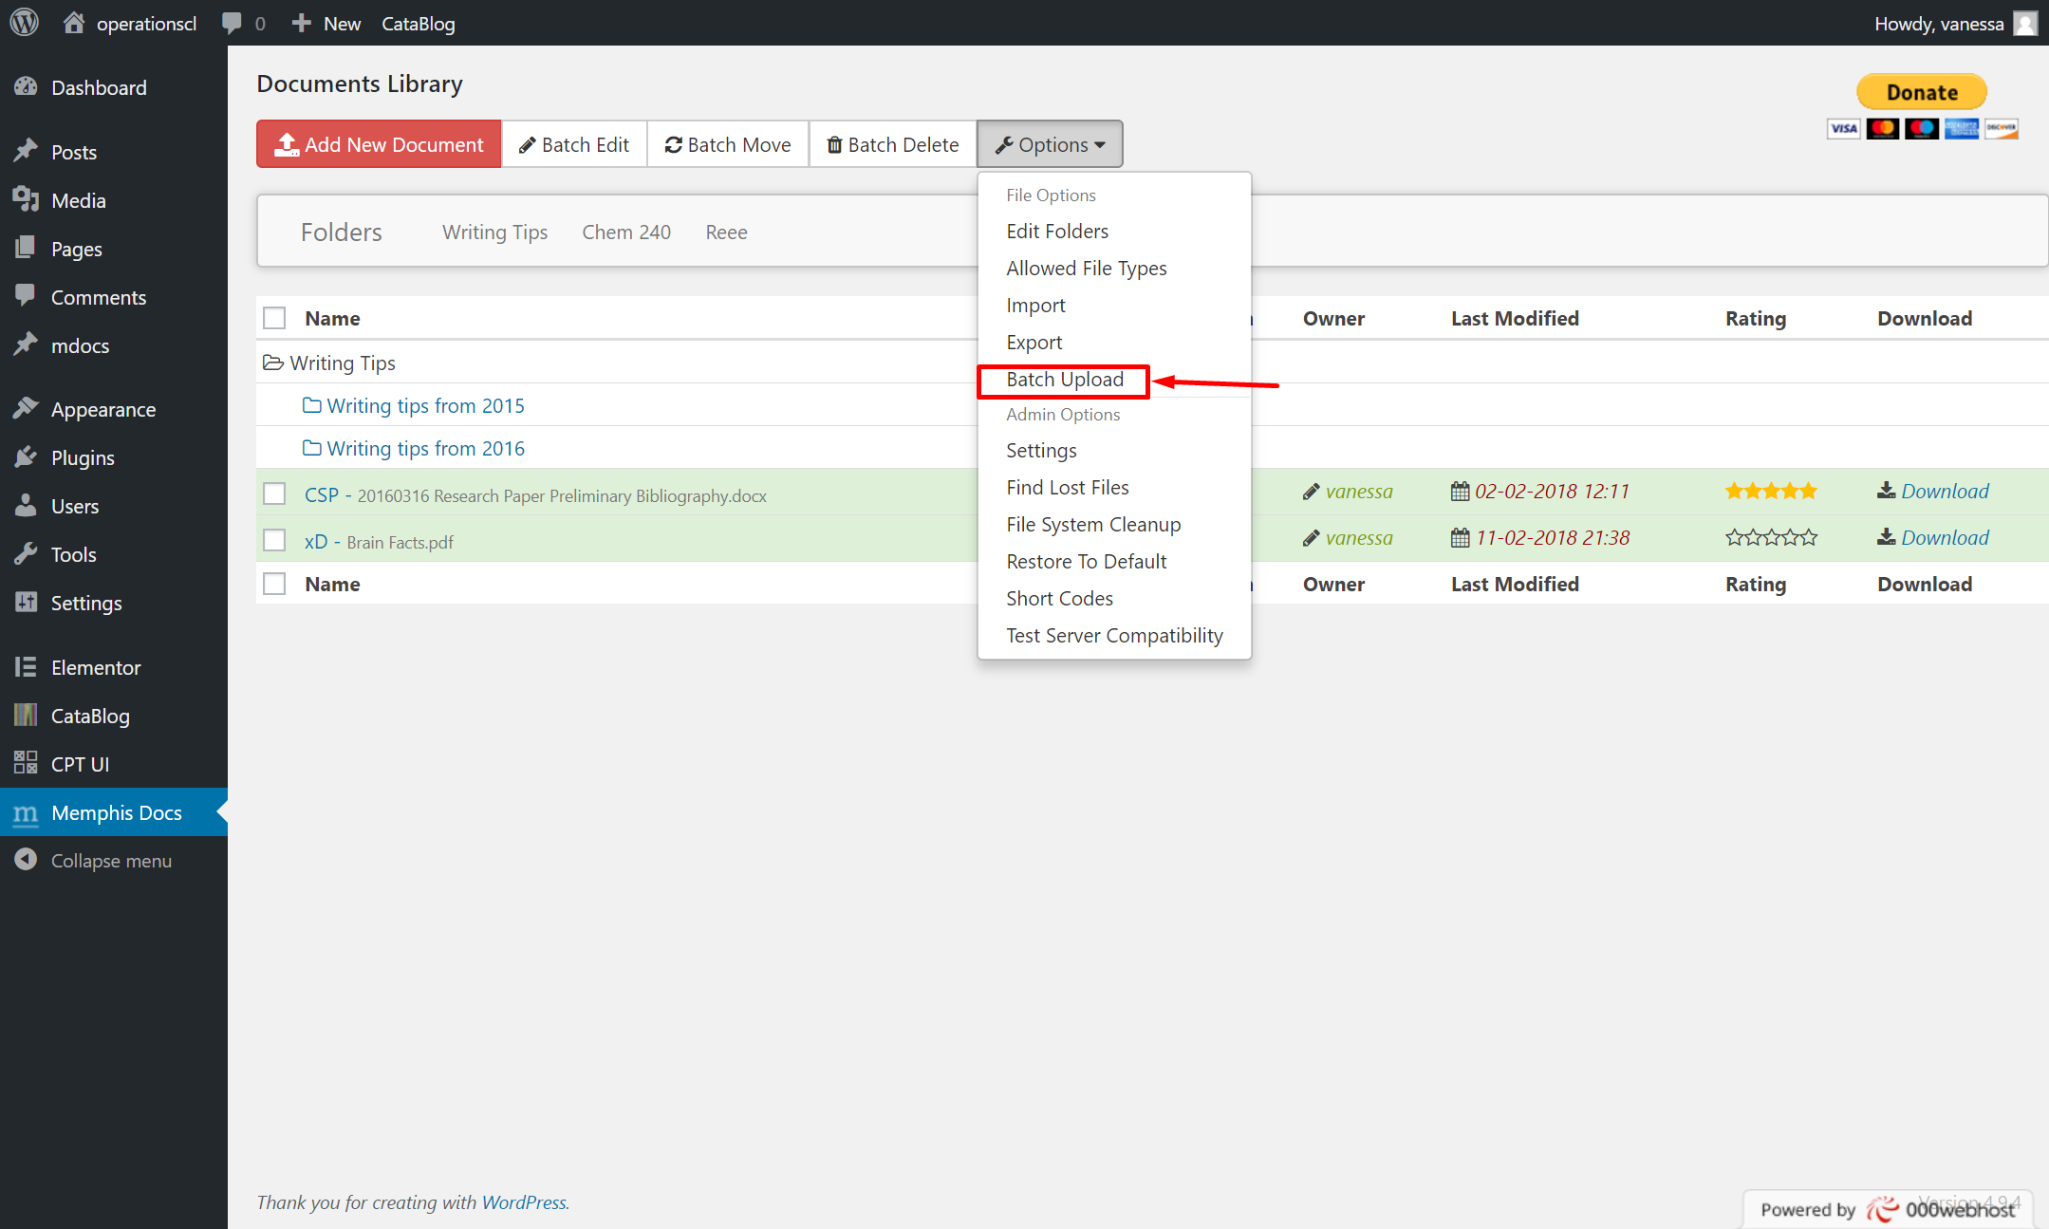

MemphisSS11

Adding Plugins to WordPress (cont.)

Configuration (cont.)

Memphis Documents (cont.)

*Adding multiple documents at once with a ZIP file (cont.)*

Choose the default folder you want the files to be uploaded to and choose your ZIP file. Then click *Upload Zip File* (MemphisSS12.png).

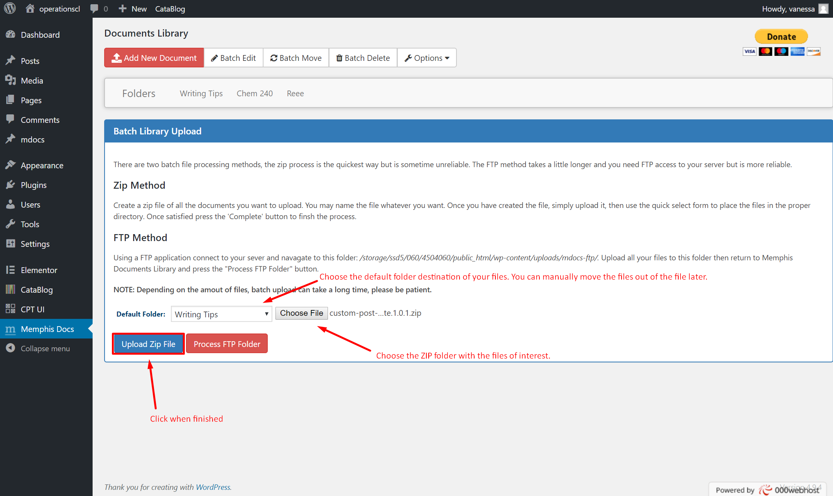

MemphisSS12

Adding Plugins to WordPress (cont.)

Configuration (cont.)

Memphis Documents (cont.)

*Adding multiple documents at once with a ZIP file (cont.)*

Then you can rename your files and change the locations. Once you are done, click *Complete* (MemphisSS13).

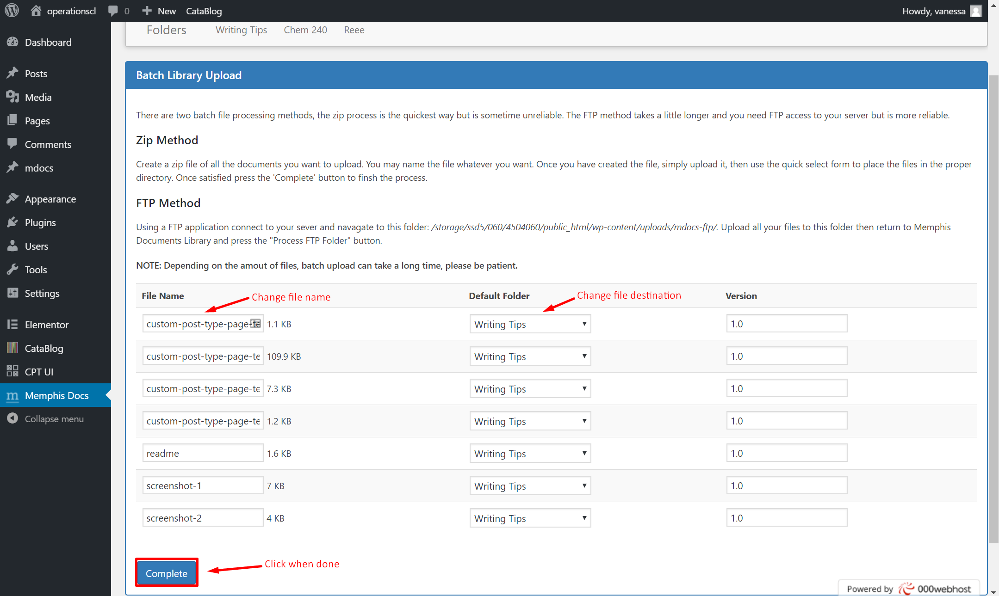

MemphisSS13

Adding Plugins to WordPress (cont.)

Configuration (cont.)

### Search & Filter

Plugin documentation from developers: [Click Here](http://docs.designsandcode.com/search-filter/)

Once you have the Search and Filter plugin activated, you can add the Search & Filter plugin onto a page with the following shortcode:

[searchandfilter fields="search"]

You can add other filters to the plugin on the page by adding them into the shortcode:

[searchandfilter fields="search, category, post_tag"]

More options and examples can be seen on <http://docs.designsandcode.com/search-filter/>

You can see what kinds of categories and tags your site has by going to the Search and Filter tab on your WordPress dashboard (SearchFilterSS01, SearchFilterSS02)

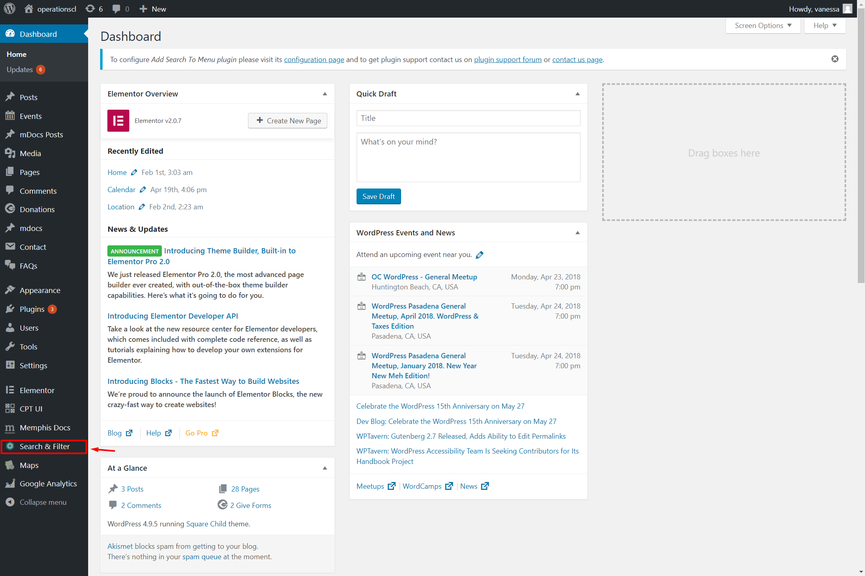  
SearchFilterSS01

Adding Plugins to WordPress (cont.)

Configuration (cont.)

Search & Filter (cont.)

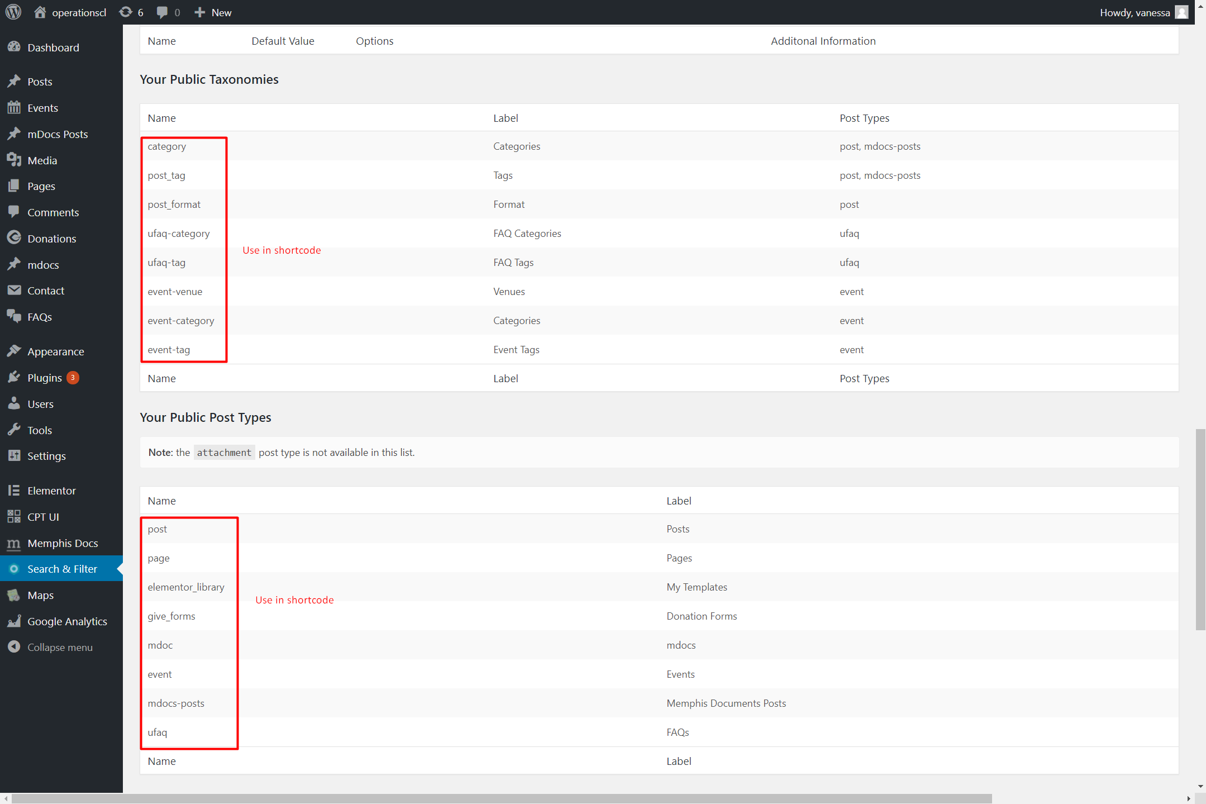  
SearchFilterSS02

Adding Plugins to WordPress (cont.)

Configuration (cont.)

### Ultimate FAQ

Plugin documentation from developers: [Click Here](http://www.etoilewebdesign.com/plugins/ultimate-faq/documentation-ultimate-faq/)

Click on *FAQ* in the WordPress admin sidebar menu

Click on *Add New*

Enter the FAQ question in the title area and the FAQ answer in the main post content area

Set the author name using the *Author Display Name* field under the main post content area

Select and/or create FAQ categories and FAQ tags in the right-side menu

Click the *Publish* button